IFN 509: Data Exploration and Mining

Assessment 2

Team Name: [          Cool      ]

Group No. [19]

|  |  |
| --- | --- |
| Student Name | Student Id |
| Naoki Kogai | n10861793 |
| Chak Ho Chan | n10954856 |
| Tak Yu Cheung | n11054522 |

|  |  |  |  |
| --- | --- | --- | --- |
|  | Naoki Kogai | Chak Ho Chan | Tak Yu Cheung |
| Naoki Kogai | <100 %> | <100 %> | < 100%> |
| Chak Ho Chan | <100 %> | <100 %> | <100 %> |
| Tak Yu Cheung | <100 %> | <100 %> | <100 %> |

Project (a): Association mining to find common items purchased based on online retail data

1. What pre-processing was required on the dataset before building the association mining model? What variables did you include in the analysis? Justify your choice.

Original Data:

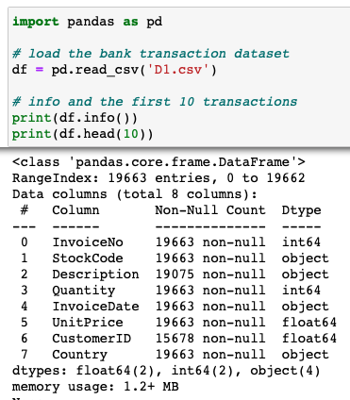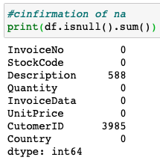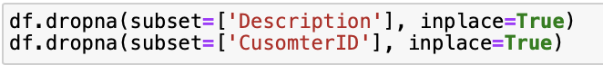

Answer: Firstly, we have identified the missing value and value inconsistencies, and there are missing values in “Description” and “CustomerID” that needed to be dropped.  This figure explains the original data type of each variable. “StockCode”, “Quantity”, “UnitPrice” are derived variables from “Description”, and “Country” is not required. According to the data set,  InvoiceDate is a date value so it should be datetime64, but the most relevant variables for the association mining in this task are “InvoiceNO '' and “Description”, in which they are independent. Therefore, the rest of the variables can be dropped.  As a result, “InvoiceNO” and “Description” are being used in association mining analysis.

1. Conduct association mining and answer the following:

a. What ‘min_support’ and `min_confidence’ thresholds were set for this mining exercise? The rationale why these values were chosen?

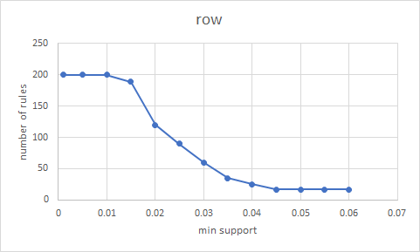

Answer: min_support=0.04, min_confidence = 0.30

After trying different combinations of min_ support, we found that the min_support lower than 0.04 did not narrow down the result anymore. Therefore we chose 0.04 as min_support because we assumed that min_support 0.04 eliminated all infrequent rules which we should not consider.

And for min_condifence, since it is not the primary concern if we are looking for the top item among transactions, therefore we chose 0.3 to eliminate rules with extremely low confidence levels.

b. Report the top-5 rules and interpret them.

The top 5 rules are listed below:

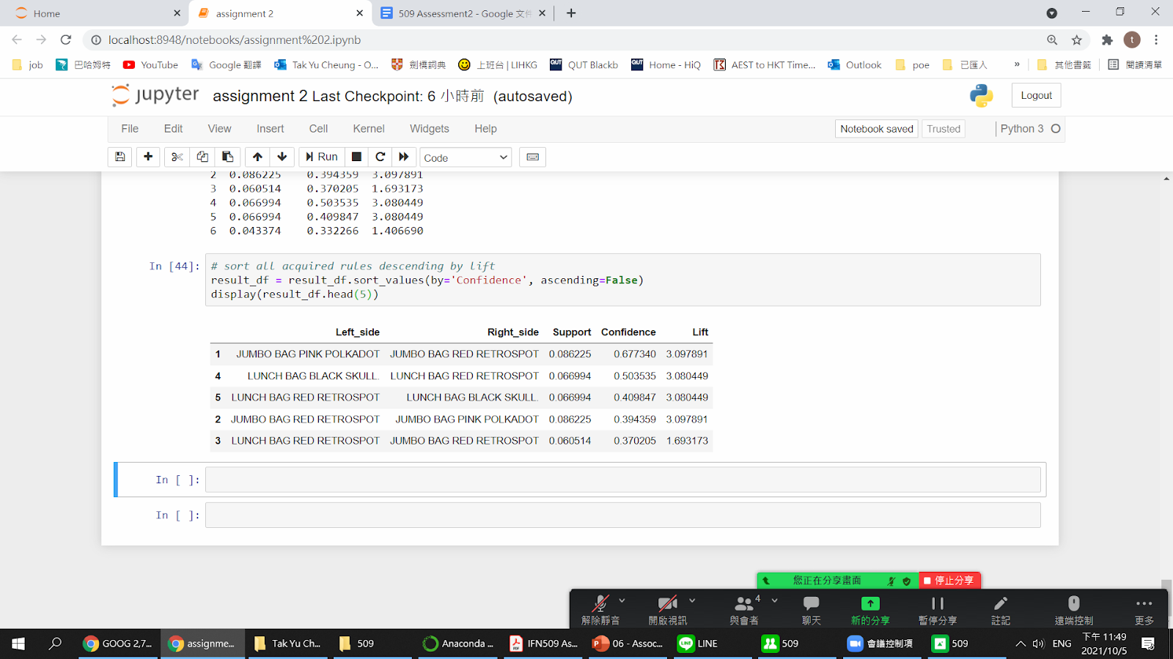

Answer: The support value means how often these two items appear together as the percentage in all transactions. Confidence value means how often the right side appears when the left side item appears in one transaction. Based on the data above, JUMBO BAG PINK POLKADOT→JUMBO BAG RED RETROSPOT is the most common rule in all transactions. 8.62% of the transaction contains these two items. The confidence value of JUMBO BAG PINK POLKADOT→JUMBO BAG RED RETROSPOT is higher than JUMBO BAG RED POLKADOT→JUMBO BAG PINK RETROSPOT which means if people bought the JUMBO BAG RED POLKADOT, they are less likely to buy the pink one.

Showing that the red jumbo bag as the left side item with the highest confidence is the most popular item among items in other top rules. And for the list value, which refers to the strength of the association, which means these top 5 rules had at 1.69 - 3.09 times more likely to be happened together due to the conscious decision of the customers rather than by chance.

1. Identify top-5 common items that customers have purchased along with ‘LUNCH BAG RED RETROSPOT’.

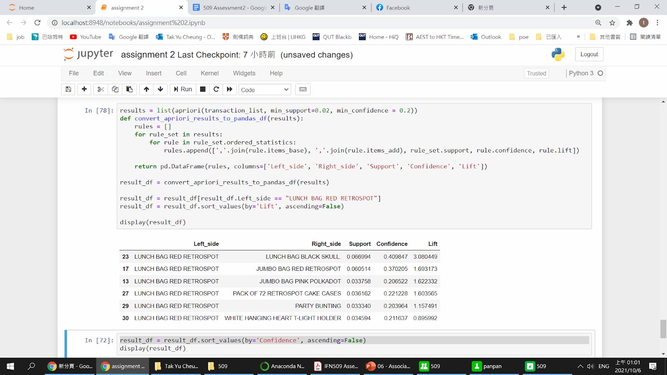



Answer: The top 5 items be purchased with LUNCH BAG RED RETROSPOT are LUNCH BAG BLACK SKULL, JUMBO BAG RED RETROSPOT, PACK OF 72 RETROSPOT CAKE CASES, PARTY BUNTING and JUMBO BAG PINK POLKADOT.  WHITE HANGING HEART T-LIGHT HOLDER is not considered because the lift is the lowest among these items. If the lift of the itemset is low meaning the association between items is weak and customers buying this item with LUNCH BAG RED RETROSPOT is likely by random chance.

1. Can you perform sequence analysis on this dataset? If yes, present your results. If not, rationalize why.

Answer:

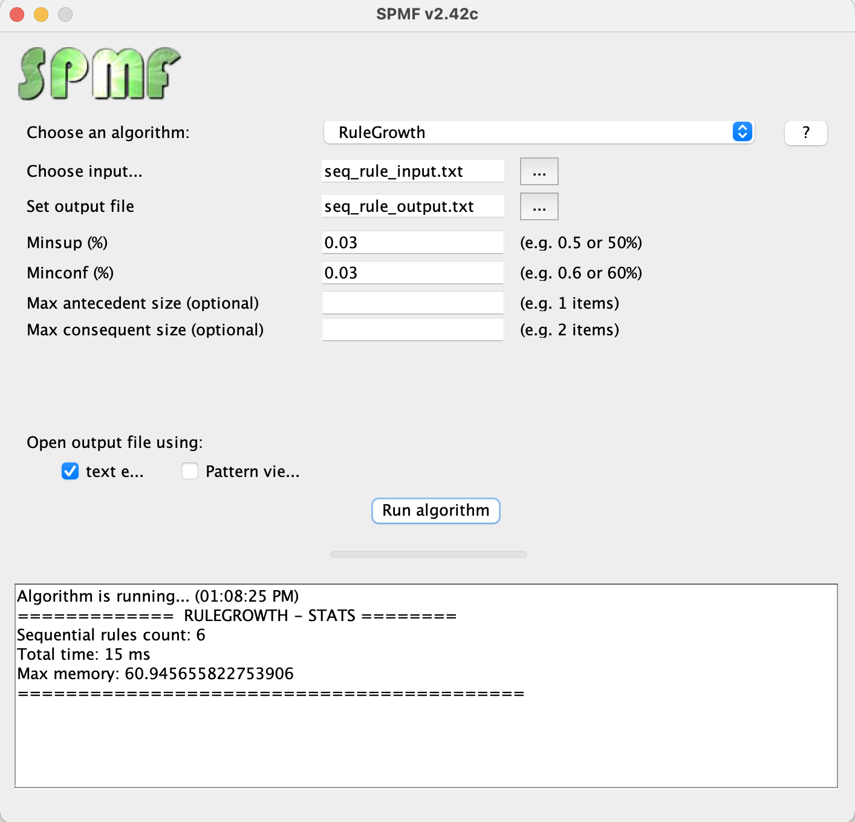

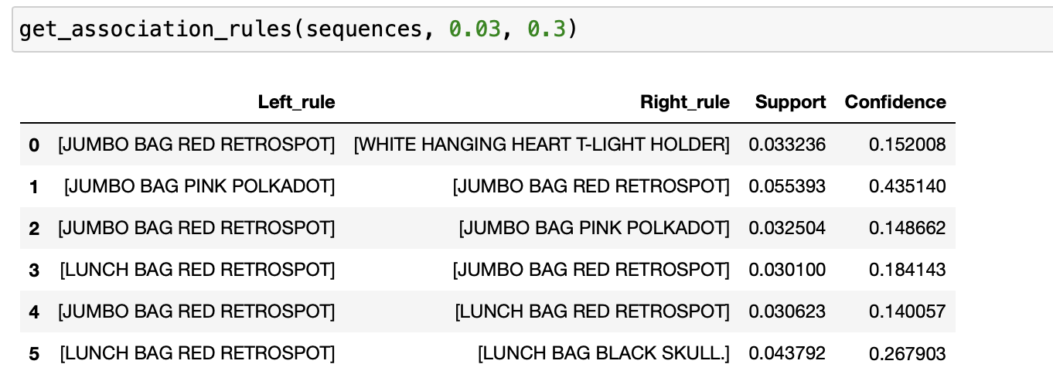  
Answer:

[JUMBO BAG RED RETROSPOT] <<>>[WHITE HANGING HEART T-LIGHT HOLDER]

[JUMBO BAG PINK POLKADOT <<>> JUMBO BAG RED RETROSPOT]

[JUMBO BAG RED RETROSPOT <<>> JUMBO BAG PINK POLKADOT]

[LUNCH BAG RED RETROSPOT <<>> JUMBO BAG RED RETROSPOT]

[JUMBO BAG RED RETROSPOT <<>> LUNCH BAG RED RETROSPOT]

[LUNCH BAG RED RETROSPOT <<>> LUNCH BAG BLACK SKULL]

1. How can the outcome of this study be used by the relevant decision-makers?

The outcome shows the combination of the best-selling products, which can be used for the strategy of setting up product bundles. For example, customers often buy LUNCH BAG RED RETROSPOT and LUNCH BAG BLACK SKULL together meaning that we do not need to put these two items together as a bundle or provide any discount to the bundle because the set is already attractive enough for the customer, an extra discount may reduce the profit and impact the sales of other items.

On the other hand, this combination can also be used for boosting the sales of other unmarketable items. For example, bundling hot items like LUNCH BAG RED RETROSPOT can sell less favourable products easier.

This information also helps decide the products placement of the store. For example, putting popular combinations further apart in the store make the customers stay longer in the store and increase the possibility to pick up other items on the way from product a to product b.

Project (b): Clustering COVID-19 Epidemiological data

1. What pre-processing was required on datasets (D2_mar.csv and D2_apr.csv) before building the clustering model?

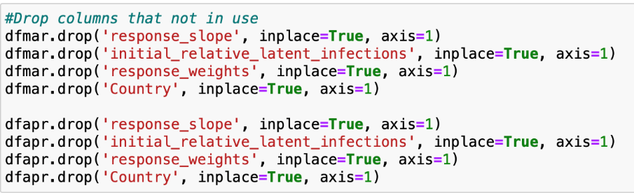

For March:

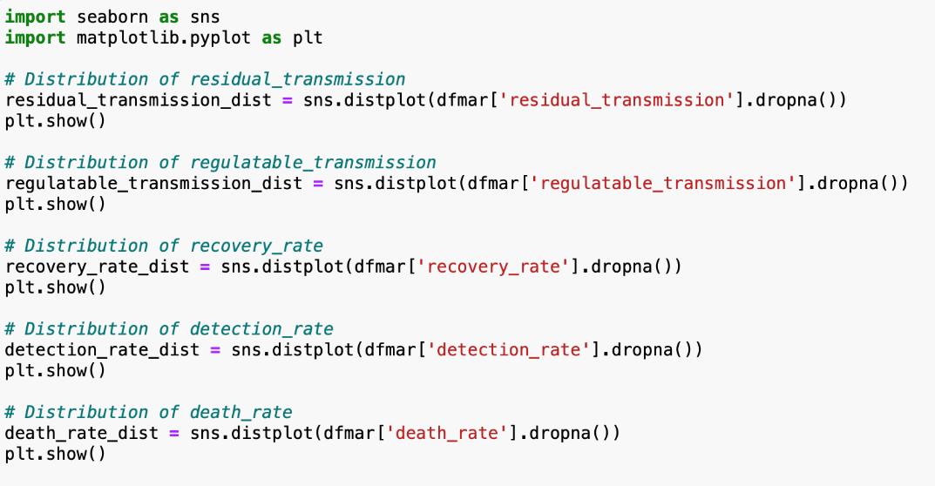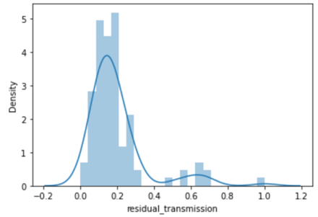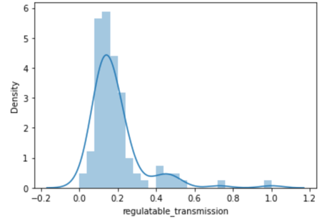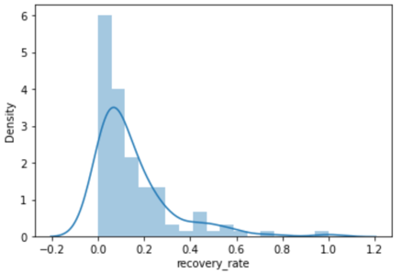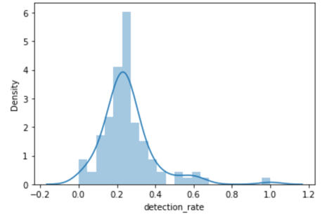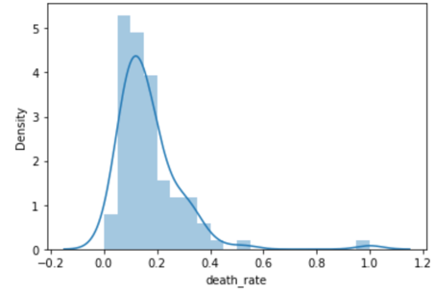

For April:

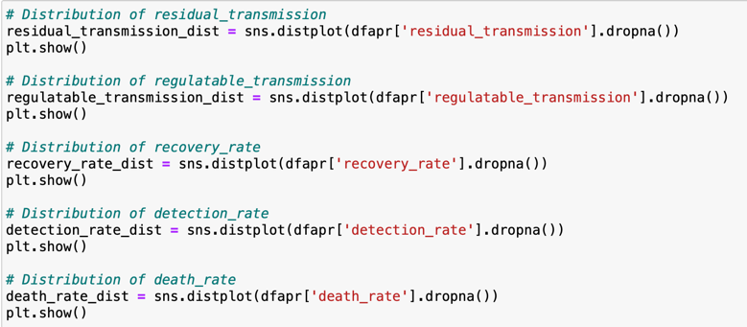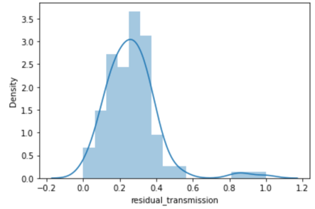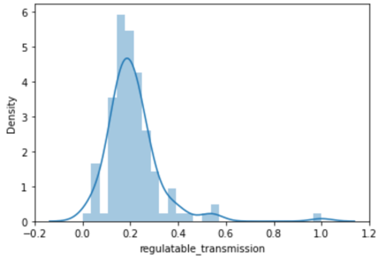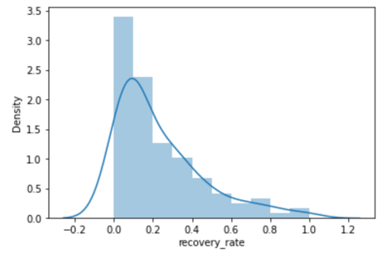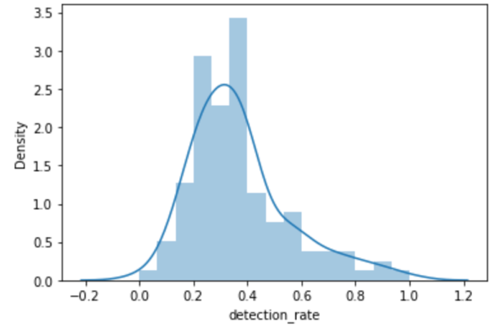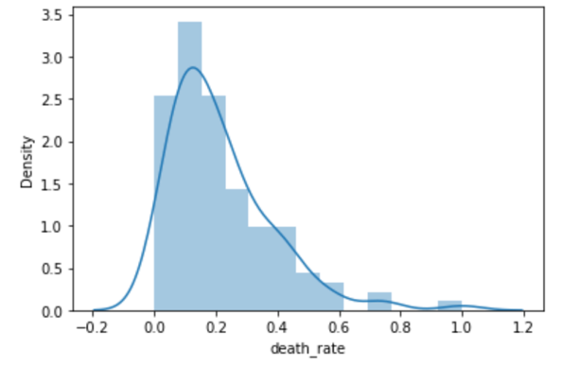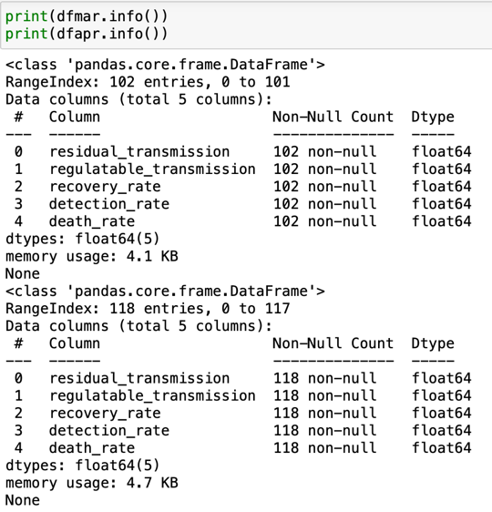

Answer: We dropped columns that do not require to be included in the cluster. And also using distplot to find out if there were any missing values.

1. Build a clustering model to profile the characteristics of countries. Answer the followings for both datasets (D2_mar.csv and D2_apr.csv):

a. What clustering algorithm have you used?

Answer: We have used K-means because we are dealing with numeric type data.

b. List the attributes used in this analysis.

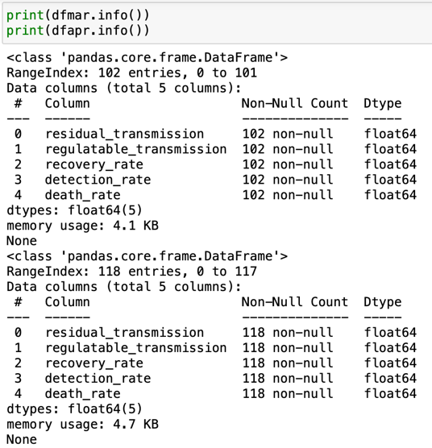

Answer:  For both Mar and Apr dataset, there are in total 5 attributes that will be used in this analysis. They are ‘residual_transmission’, ‘regulatable_transmission’, ‘recovery_rate’, ‘detection_rate’, ‘death_rate’.

c. What is the optimal number of clusters identified? How did you reach this optimal number?

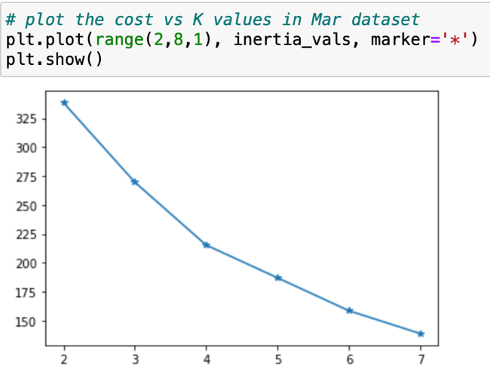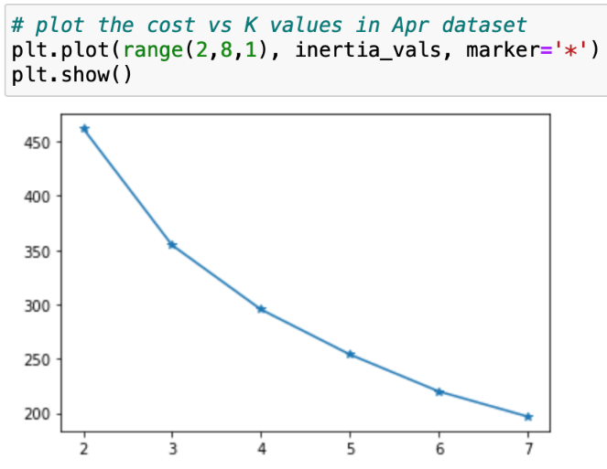

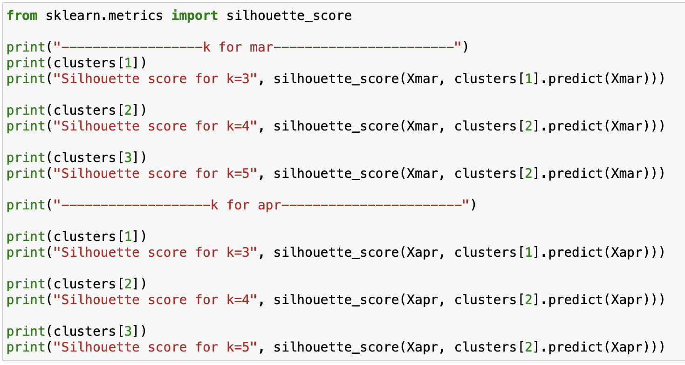

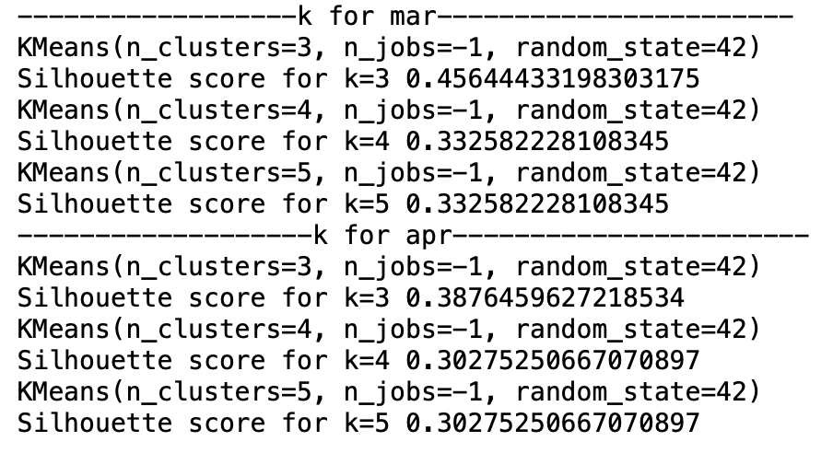

Answer: We used elbow method to find optimal K. And in order to get more accurate K, we compare silhouette_score of k=3,k=4 and k=5 for the March and April dataset. The results show k = 3 is a better number of clusters for the March and April dataset.

 d. Did you normalise the variables? What was its effect on the model – Does the variable normalization process enable a better clustering solution?

Answer: No, because the values from March and April dataset are reported in standardised form of its original values. The reason for using normalization is category data, such as using one-hot encoding. The values in our datasets are numeric and standardised form, therefore, there is no need to perform normalization.

1. For the model with the optimal number of clusters, answer the following for both datasets (D2_mar.csv and D2_apr.csv).  
    a. Visualize the clusters using ‘pairplot’ and interpret the visualization.

March dataset:

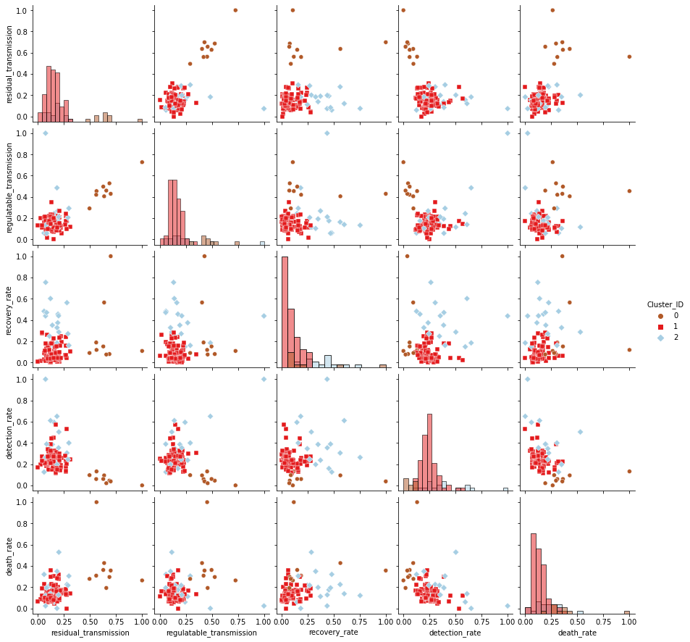

April dataset:

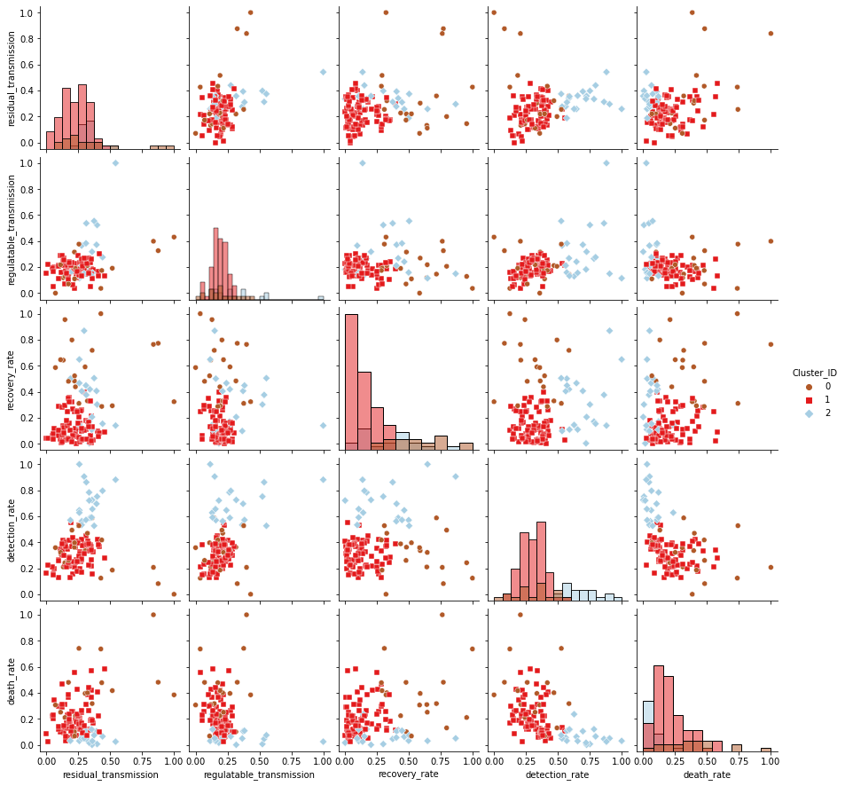

|  |  |
| --- | --- |
| March dataset: | April dataset: |
| Cluster 0 (brown): | |
| High residual transmission and high death rate  Low Detection rate Low recovery rate and high residual and regulatable transmission | High recovery and low residual and regulatable transmission Medium Detection rate and high recovery rate Medium Death rate and high recovery rate |
| Cluster 1 (red): | |
| Low Recovery rate, residual and regulatable transmission Low Death rate and Detection rate | Medium death rate and low regulatable transmission  Medium detection rate and low death rate |
| Cluster 2 (blue): | |
| Regulatable transmission and residual transmission rate is low Recovery rate is high when residual and regulatable transmission is low Detection rate is high and recovery rate is high, but residual and regulatable transmission is low Death rate is low when recovery is high | The detection rate is high and the death rate is low in general.  Medium residual and regulatable transmission rate. |

Answer:

The above pairplot visualizes the relationships between variables in the dataset. As shown in the pairplot, this dataset has 3 clusters. The red cluster (cluster 0) is the most dominant. Based on the understanding, residual transmission is some transmission that that is leftover after introducing regulations whereas regulatable transmission is the transmission that can control over some protection or government regulation.

1. Characterize the nature of each cluster by giving it a descriptive label and a brief description. Hint: use cluster distribution.

March dataset:

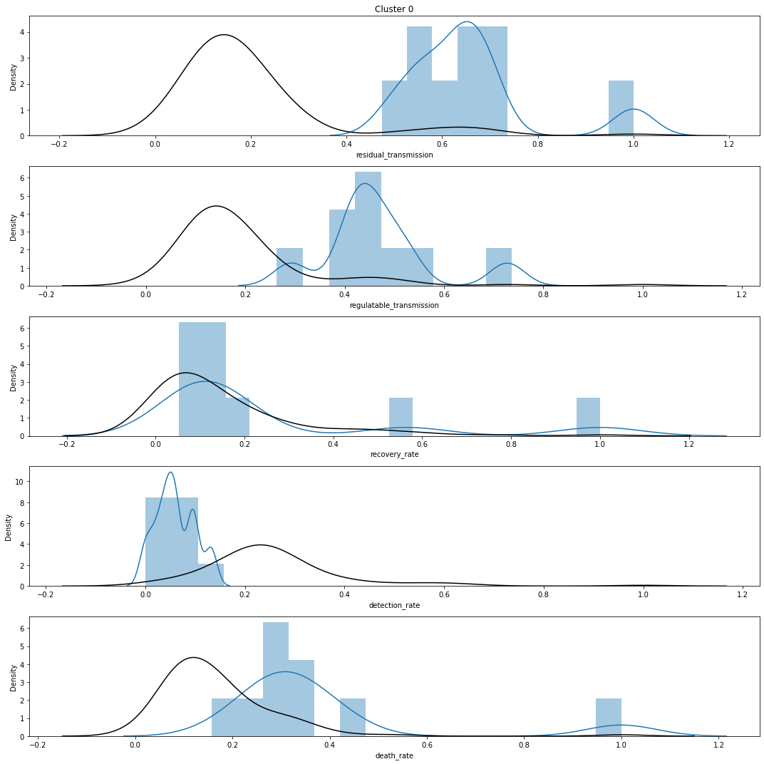

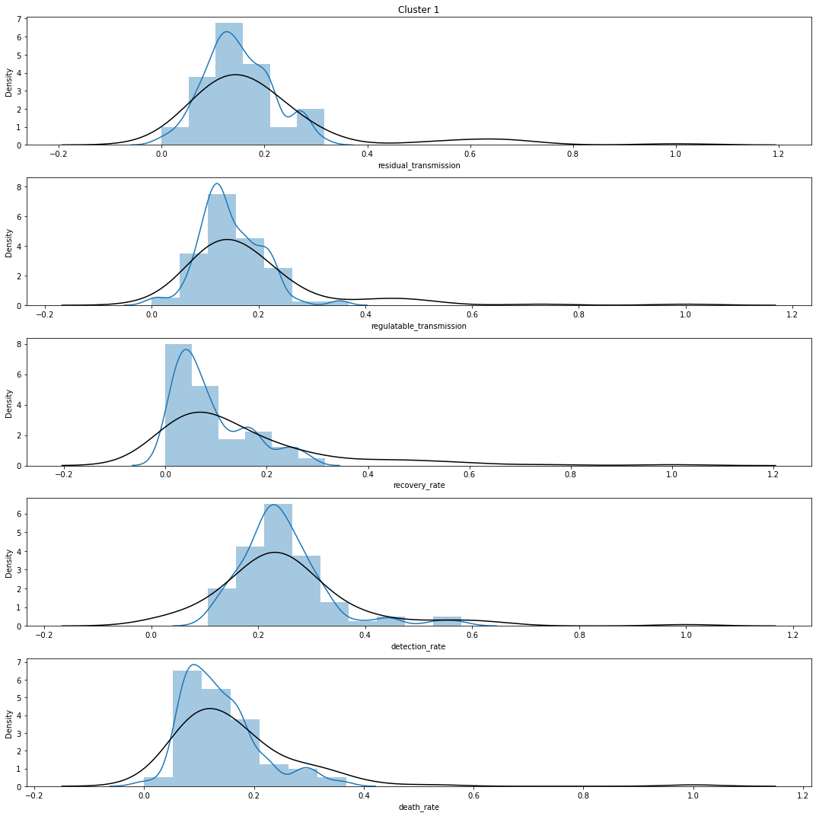

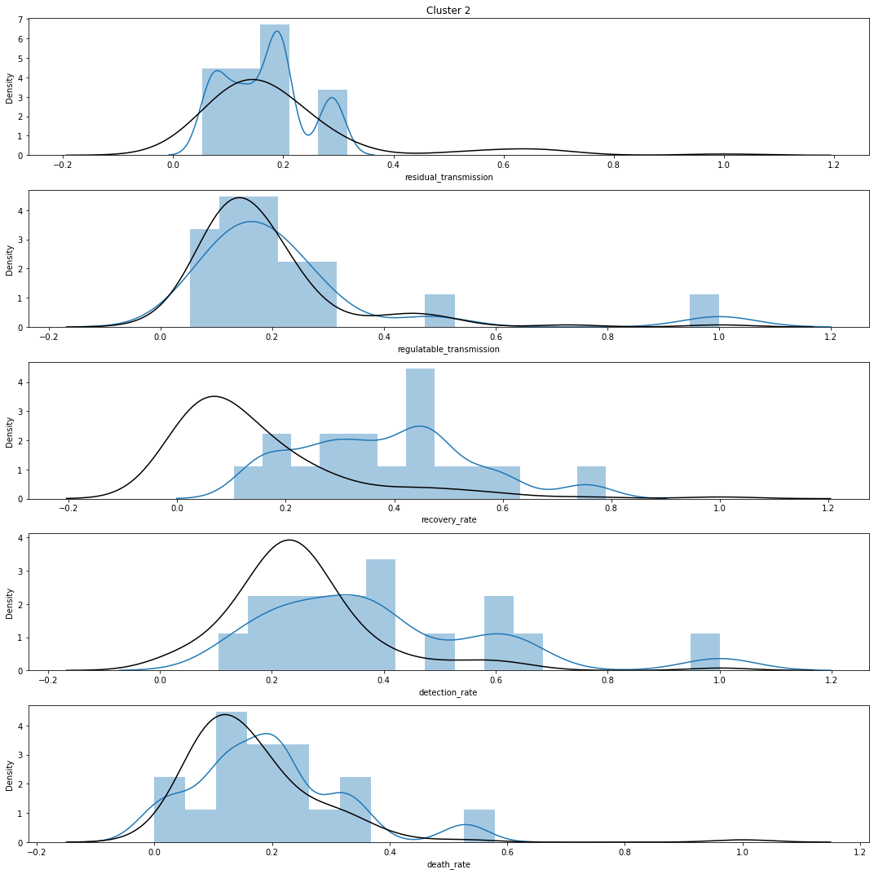

April dataset:  
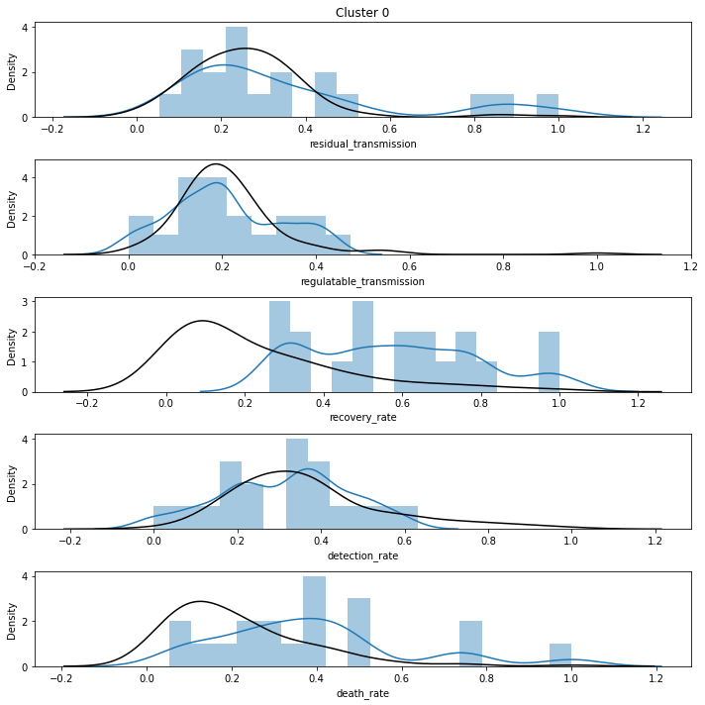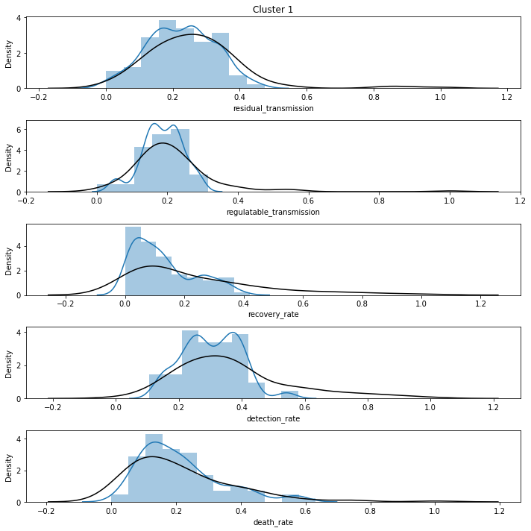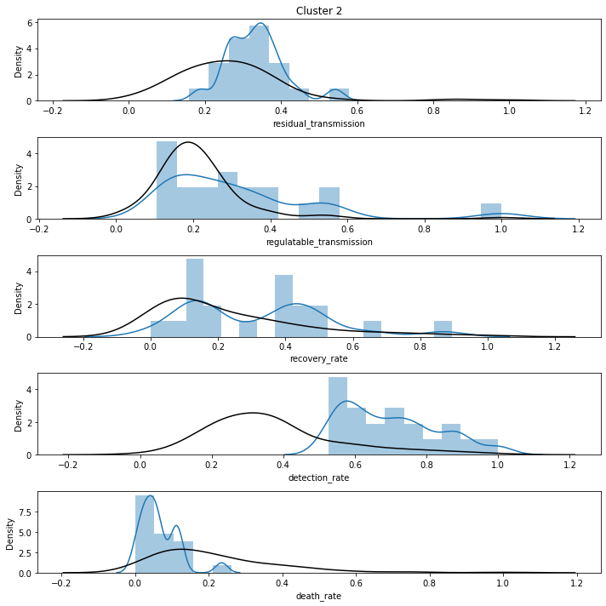

Answer: According to cluster 0 in March, the transmission rate was 2-3 times higher than average. The detection was very low. Therefore, this cluster of countries are seriously suffering and should invest more on health protection. Whereas for cluster 2 countries, being very cautious and good control of COVID transmission. Therefore, countries in cluster 2 were doing good against the pandemic.

|  |  |  |
| --- | --- | --- |
| March | | |
| Cluster 0 |  | Descriptive lable |
| High residual transmission  High regulatable transmission  High recovery | Low detection rate  High death | Relatively serious countries |
| Cluster 1 |  | Descriptive lable |
| Similar residual transmission  Similar detection | Low recovery rate  Low death rate  Low regulatable transmission | Medium serious countries |
| Cluster 2 |  | Descriptive lable |
| High recovery  High detection  Low  residual and regulatable  transmission | Low death rate | The least serious countries |
| April | | |
| Cluster 0 |  | Descriptive lable |
| High recovery  High death | Low  residual and regulatable  transmission  Similar detection rate | Relatively serious countries |
| Cluster 1 |  | Descriptive lable |
| Similar recovery rate  Similar detection rate | Low  residual and regulatable  transmission  Low death rate | Medium serious countries |
| Cluster 2 |  | Descriptive lable |
| High recovery  High detection | Low death rate | The least serious countries |

1. Using the best setting (e.g., variable normalisations, optimal K, etc) obtained in the previous models, profile clusters in both datasets. Compare the results of clusters for D2_mar.csv and D2_apr.csv. How the behaviour of countries changed from March to April?

Answer: Comparing the behaviour in March and April, the number of death-rate, recovery rate and residual-transmission were reduced. To take an example of death-rate in cluster 0, the distribution of bar-graph is closer to 0. The reason is that the number of regulatable-transmission was higher than that of April in March, so it is expected that infection control measures were taken sufficiently. As a result of this, the number of residual-transmission was reduced, and recovery-rate and death-rate were improved.

|  |  |  |  |  |
| --- | --- | --- | --- | --- |
|  | | Cluster 0 | Cluster 1 | Cluster 2 |
| March | High | ・residual transmission  ・regulatable transmission  ・recovery rate  ・death rate | ・Similar residual  ・transmission  ・Similar detection | ・recovery rate  ・detection rate |
| Low | detection rate | ・recovery rate  ・death rate  ・regulatable transmission | ・residual and regulatable transmission  ・death rate |
| Label | Relatively serious countries | Medium serious countries | The least serious countries |
| April | High | ・recovery rate  ・death rate |  | ・recovery rate  ・detection rate |
| Low | ・residual and regulatable transmission  ・Similar detection rate | ・residual and regulatable transmission rate  ・death rate  ・recovery rate  ・detection rate | ・death rate |
| Label | Relatively serious countries | Medium serious countries | The least serious countries |

|  |  |  |
| --- | --- | --- |
| March - Cluster membership | | |
| Relatively serious countries | Medium serious countries | The least serious countries |
| 9 (8.8%) | 76(74.5%) | 17 (16.6%) |
| April | | |
| Relatively serious countries | Medium serious countries | The least serious countries |
| 19 (16.6%) | 79 (66.6%) | 20 (16.7%) |

By studying countries that performed better in March, we notice that they tend to have better detection rates and recovery rates toward COVID 19 disregarding the transmission rate. These two factors help the countries maintain a low death rate.

More countries fall into serious countries in April, the percentage increased from 8.8% to 16.6%. However, compared with the serious countries in March, they had a slightly higher average rate of detection and recovery. The average detection and recovery rate of this cluster skewed right after one month. It showed that the serious countries may learn from the better countries to put more effort into these two aspects of the medical system to conquer the pandemic. Besides, by increasing the detection rate, the serious countries also drop the residual transmission rate from 0.6 to 0.2, which is closer to the world average.

Project (c): Building and Evaluating Predictive models

**Predictive modelling using Decision Tree**

1. What processing was required on this pre-processed dataset (D3.csv) to further improve the data quality for decision tree modelling? What distribution split between training and test datasets have you used?

Since the data is cleaned already, which means containing no outlier or error data, we can focus on how to trim down the data complexity to decrease the consumption of calculation capacity.

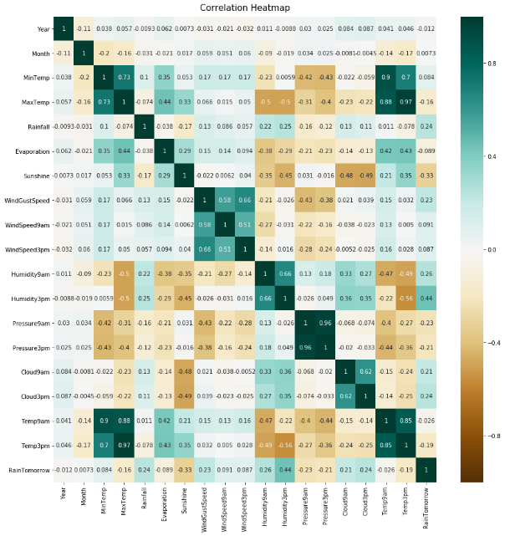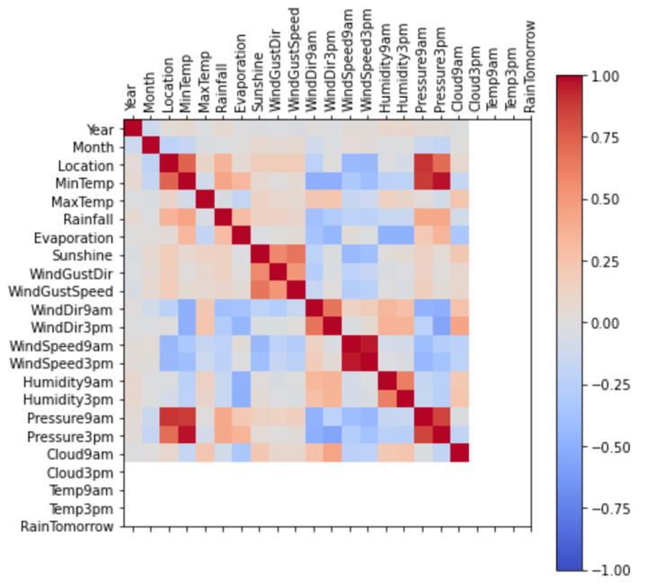

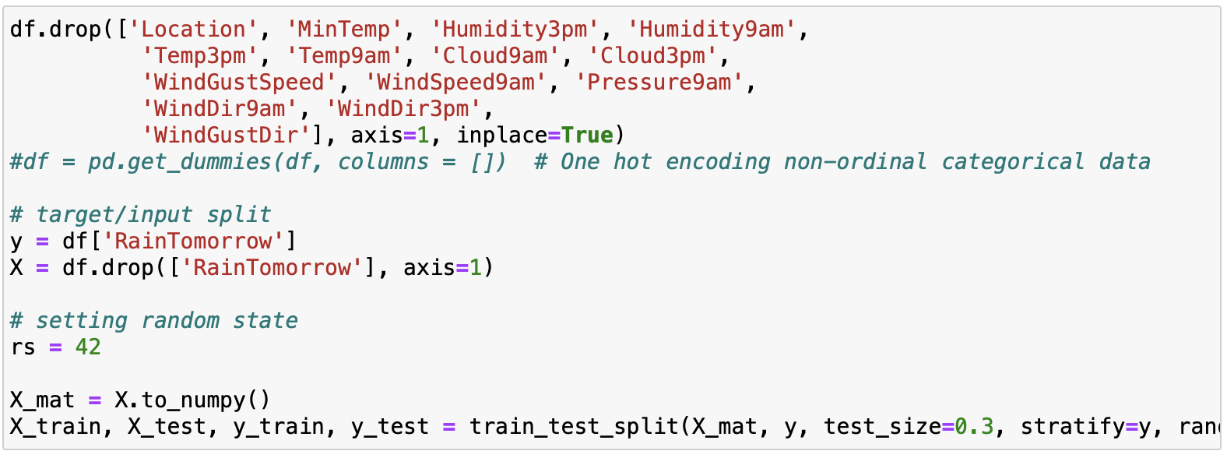

Answer:   
The above diagrams show how variables correlated with each other. On the left hand side, it shows all the relation of the numeral variable. On the right hand side, the diagram shows the rest of correlations paired with categorical data. In Decision tree mining, data with high correlation coefficient represents that they are derived variables, which means the same piece of information is being represented in different ways. In order to reduce the burden of data mining, the following derived variables will be dropped:

Location, WindDir9am, WindDir3pm, Pressure9am, Pressure3pm, Humidity9am, Humidity3pm, WindGustSpeed, WindSpeed9am, WindSpeed3pm, WindGustDir, Cloud3pm

Then, ‘RainTomorrow’ is the target variable that needs to be split into a training set and test set. It is set 70% as training and 30% as a test.

2. Build a decision tree using the default setting. Answer the followings:

a. What is the classification accuracy of training and test datasets?

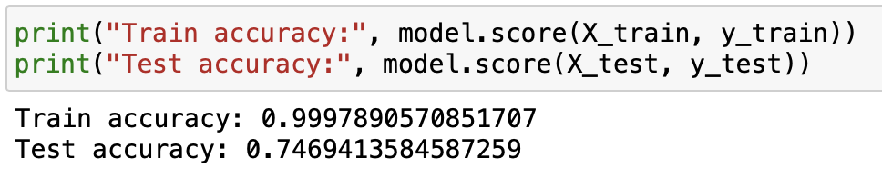

Answer: The training accuracy is about 99% and test accuracy is about 75%

b. What is the size of the tree (i.e., number of nodes and rules)?

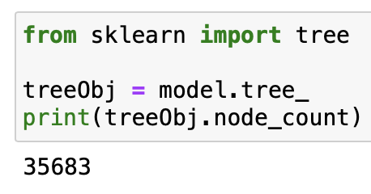

Answer: The total number of nodes and rules are 35683 by the default setting.

c. Which variable is used for the first split?

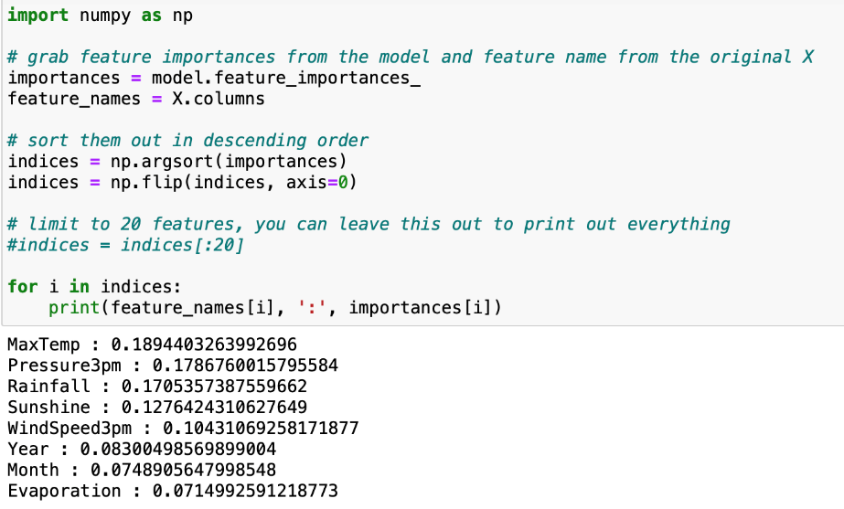

Answer: The variable is used for the first split is MaxTemp.

d. What are the 5 important variables (in order) in building the tree?

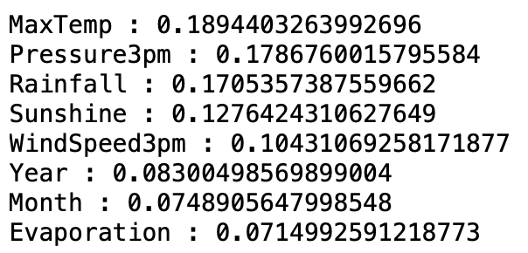

Answer:

MaxTemp : 0.1894403263992696

Pressure3pm : 0.1786760015795584

Rainfall : 0.1705357387559662

Sunshine : 0.1276424310627649

WindSpeed3pm : 0.10431069258171877

e. What parameters have been used in building the tree? Detail them.

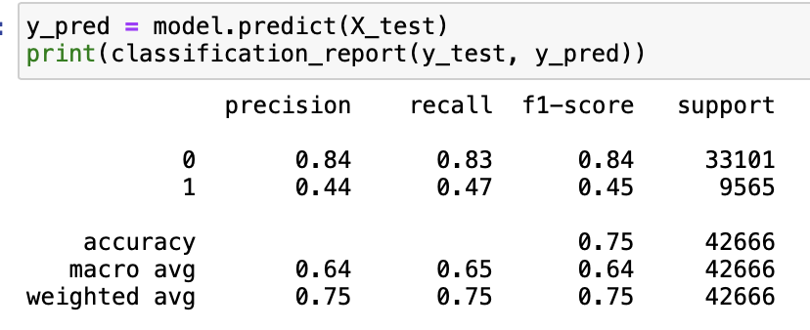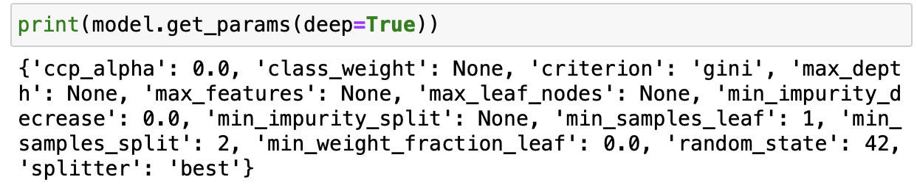

Answer: The default parameters are:

 {'ccp_alpha': 0.0, 'class_weight': None, 'criterion': 'gini', 'max_depth': None, 'max_features': None, 'max_leaf_nodes': None, 'min_impurity_decrease': 0.0, 'min_impurity_split': None, 'min_samples_leaf': 1, 'min_samples_split': 2, 'min_weight_fraction_leaf': 0.0, 'random_state': 42, 'splitter': 'best'}

There is also a classification report that shows the parameters used to assess the performance of the decision tree, they are precision, recall, f1-score and support. “Precision” is the correctness of all positive predictions; “recall” is the real positive of how many actual positive observations; “F1” is the harmonic mean of precision and recall; the last one “support” is the number of instances in every class.

3. Build another decision tree tuned with GridSearchCV. Answer the followings:

a. What is the classification accuracy of training and test datasets?

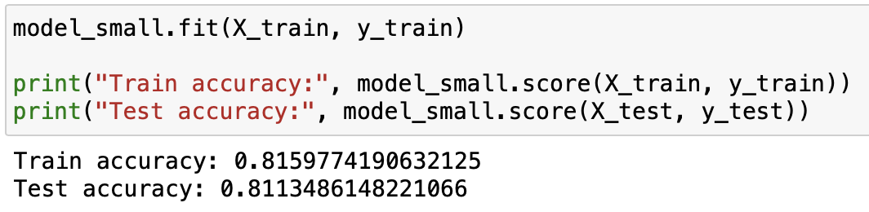

b. What is the size of the tree (i.e., number of nodes and rules)?

Since the data is cleanthis problem, it is necessary to determine the depth and maximum value of the hierarchy in advance. ed already, which means containing no outlier or error data, we can focus on how to trim down the data complexity to decrease the consumption of calculation capacity.

Answer:  After optimal hyperparameters with GridSearchCV, the number of nodes and rules are 245.

c. Which variable is used for the first split?

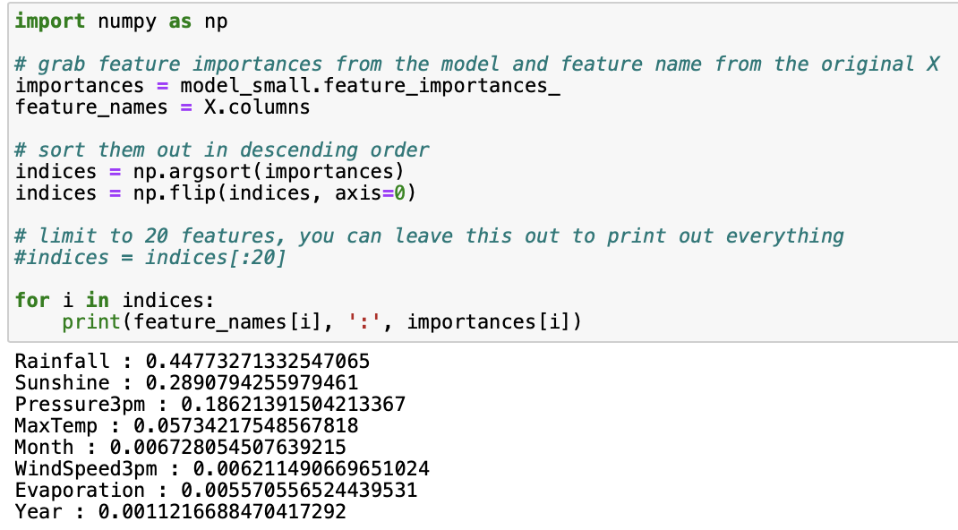

Answer: The first split is Rainfall after optimal hyperparameters with GridSearchCV.

1. What are the 5 important variables (in order) in building the tree?

Answer: The 5 important variables in building the new tree are as follow:

Rainfall: 0.44773271332547065

Sunshine: 0.2890794255979461

Pressure3pm : 0.18621391504213367

MaxTemp : 0.05734217548567818

Month : 0.006728054507639215

e. Report if you see any evidence of model overfitting.

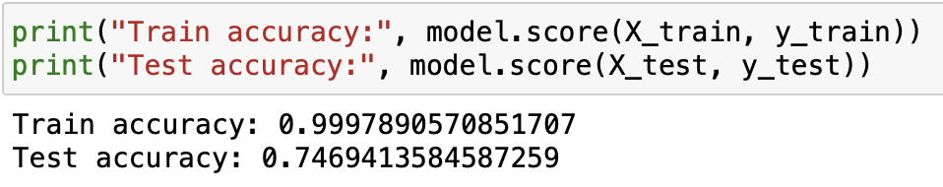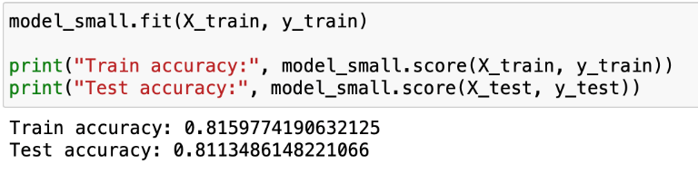

Answer: The training accuracy of the default decision tree was 99% and test accuracy was 75%.This evidence of model overfitting in which the learned model is overfitted to the training dataset. This means the model may provide wrong results and an overfitting model tends to perform badly outside the training dataset. The more ideal one should be the right one because the training accuracy and test accuracy are similar which means the performance of the result in  training and real data are similar.

1. What differences do you observe between these two decision tree models (with and without fine-tuning)? How do they compare performance-wise? Produce the ROC curve for both DTs. Explain why those changes may have happened.

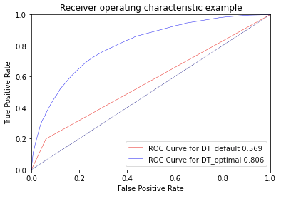

Answer: The first model adapted the default settings and caused an overfitting problem. It also took a very long time to build the tree model since there were no limitation controls in the building. The training set has 99% accuracy while the test set has 75% accuracy. Since there was no setting of any limit before building the decision tree, then the classifier would process all the tasks, so it is causing overfitting. Then the second decision tree model with optimal hyperparameters gets 81% for both the training set and the test set. As it can be seen in the Receiver Operating Characteristic(ROC), the performance of DT_default is 0.569. After optimal, it is now 0.806. Generally, the curve is showing the performance of the model on different threshold values. When the curve is closer to the top left, it means the model is better.

5. From the better model, can you provide general characteristics that infer the model to predict rain tomorrow?

Answer: In this optimal model, the tree has a  max depth of 7.  The decision tree graph is generated and found some of the general characteristics to predict rain tomorrow are as follow:

1. Rainfall is less than 0.75[77234]>Sunshine is greater than 5.85[10777] but less than 9.35[57373]> Pressure 3pm is greater  than 1011.05[6799] but less than 1019.25[32058]>MaxTemp is greater  than 21.65[3441]> Rainfall is less than 0.05[13293] > Rain Tomorrow[12066].

2. Rainfall is less than 0.75[77234]>Sunshine is greater than 5.85[10777] but less than 9.35[57373]> Pressure 3pm is greater  than 1011.05[6799] but less than 1019.25[4365]>WindSpeed3pm is greater than 34.0[11602] >Rainfall is less than 0.35[11419] > Rain Tomorrow[10699].

**Predictive modelling using Regression**

1. What processing was required on this pre-processed dataset (D3.csv) to further improve the data quality for regression modelling? What distribution split between training and test datasets have you used?

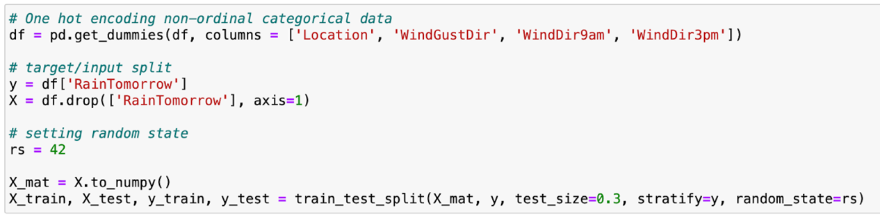

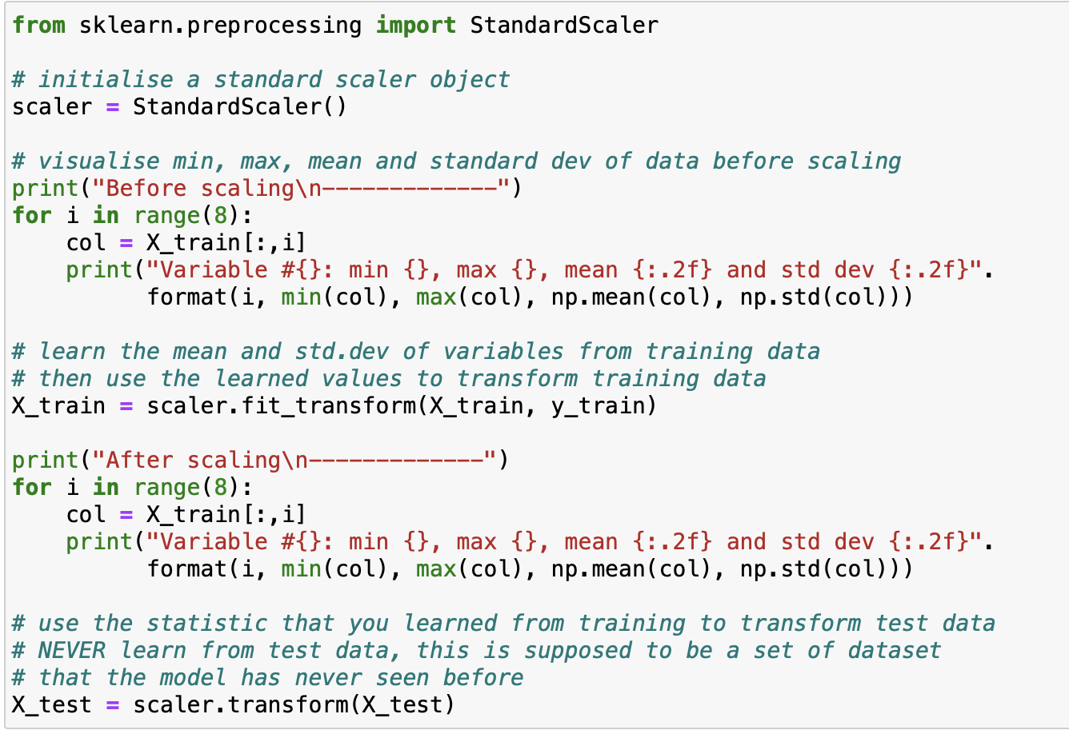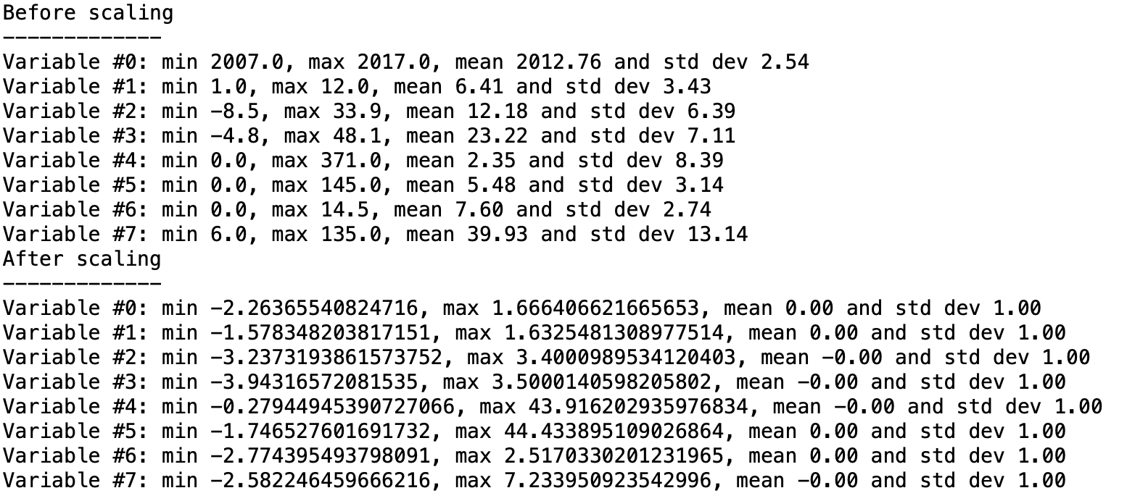

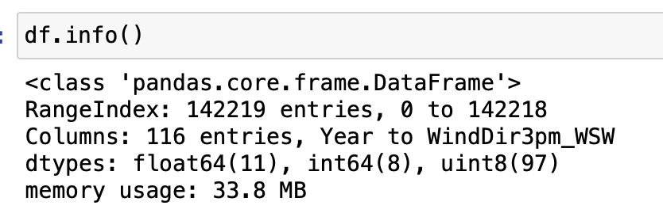

Answer:

Firstly, all the non-numerical data need to be one-hot encoding into binary.

Secondly, standardising the processed data is needed since regression models are quite sensitive to the input variables with different scales. It also makes comparison between data points more easy with standardization.

2. Build a regression model using the default regression method with all inputs. Build another regression model tuned with GridSearchCV. Now, choose a better model to answer the followings:

a. Explain why you chose that model. 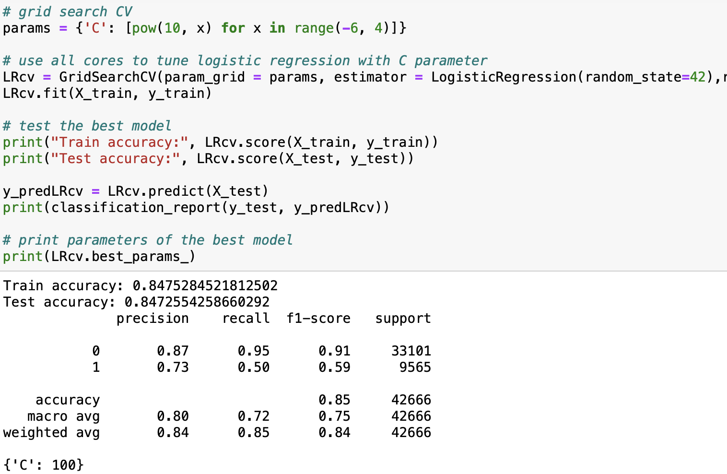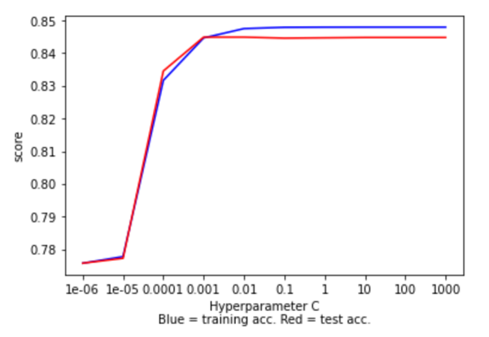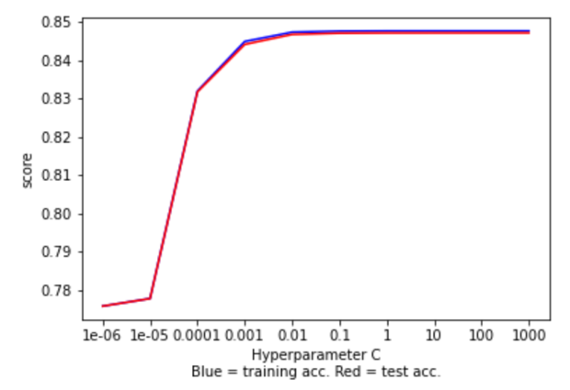

Answer: It is because the task requires a classification to whether it will rain tomorrow , and with GridSearchCV will be able to find the optimal parameter set to the model. The figure on the left used the default regression method while the figure on the right used the optimal hyperparameter with GridSearchCV. It is clear that the default one has a difference of training and test accuracy from 0.001 and it causes the model to be overfitting, the optimal version is better and has caused relatively less overfit. Therefore, the regression model tuned with GridSearchCV is a better model to be used.

b. Name the regression function used.

Answer:

Sigmoid function , because logistic regression is used as a predictive model analysis technique, looking for ‘RainTomorrow’  is the probability of occurrence of a binary value. It can convert the outcome into categorical value(1 = Yes or 0 = No).

c. Did you apply standardization of variables? Why would you normalise the variables for regression mining?

Answer:

Yes, since the input variables are sensitive with different scales. It is very important to standardise when the compare measurements are having different units and variables measured at different scales cannot contribute to the analysis fairly and may lead to biased results.

d. Report the variables included in the regression model.

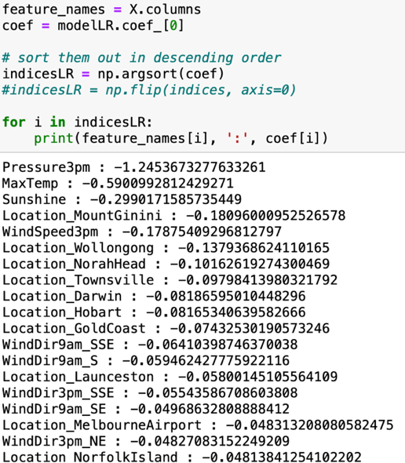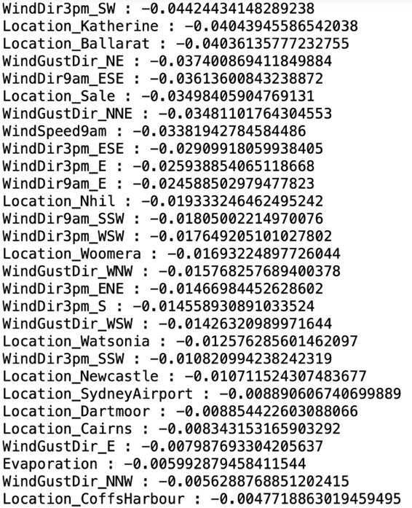

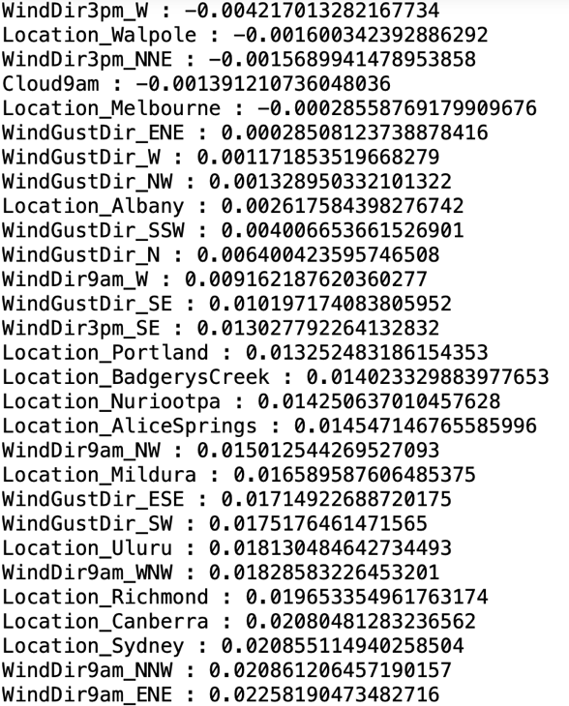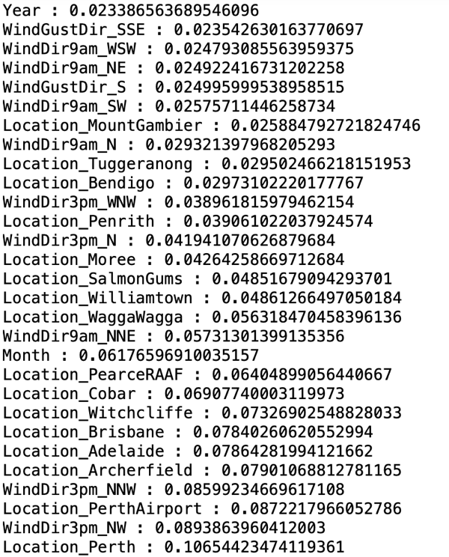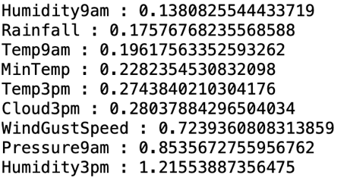

Answer:

All the variables are included. There are 116 variables in total, because one-hot encoding was applied on 'Location', 'WindGustDir', 'WindDir9am', 'WindDir3pm'.

e. Report the top-5 important variables (in the order) in the model.

Answer: Based on this output, the top-5 important variables in this model are Evaporation, Month, Year, WindSpeed3pm and Sunshine.

f. What is the classification accuracy on training and test datasets? 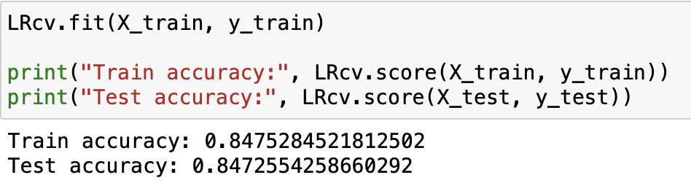

Answer: Train accuracy is 0.8475 and test accuracy is 0.8472 for the optimal logistic regression model.

g. Report any sign of overfitting in this model.

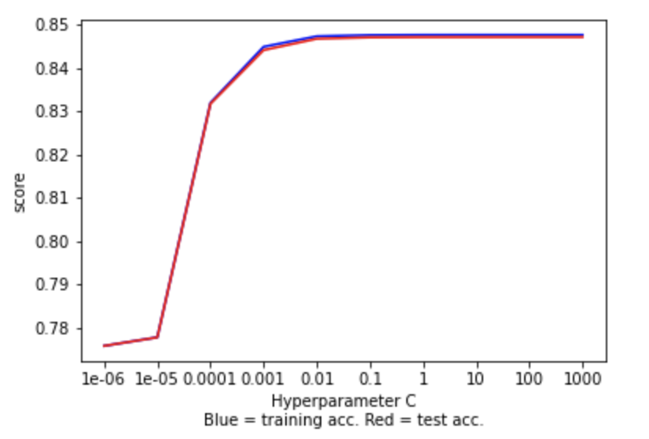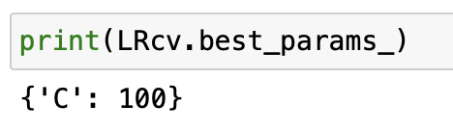

Answer: In the optimal model tuned with GridSearchCV has no sign of overfitting. The best test score with C = 100 selected as the optimal value. The mean of train score and mean of test score are very close to each other.

3. Build another regression model on the reduced variables set. Perform dimensionality reduction with recursive feature elimination. Tune the model with GridSearchCV to find the best parameter setting. Answer the followings:

a. Was dimensionality reduction useful to identify a good feature set for building the accurate model?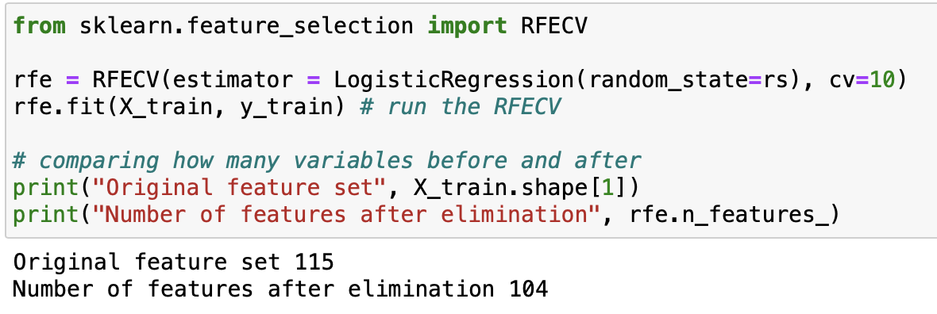

Answer:  Yes, it reduces the size of the feature set by removing the unnecessary features, and it will increase the accuracy of the model and reduce overfitting. Dimensionality reduction is divided into two processes, that are feature selection and feature extraction.

b. What is the classification accuracy on training and test datasets?

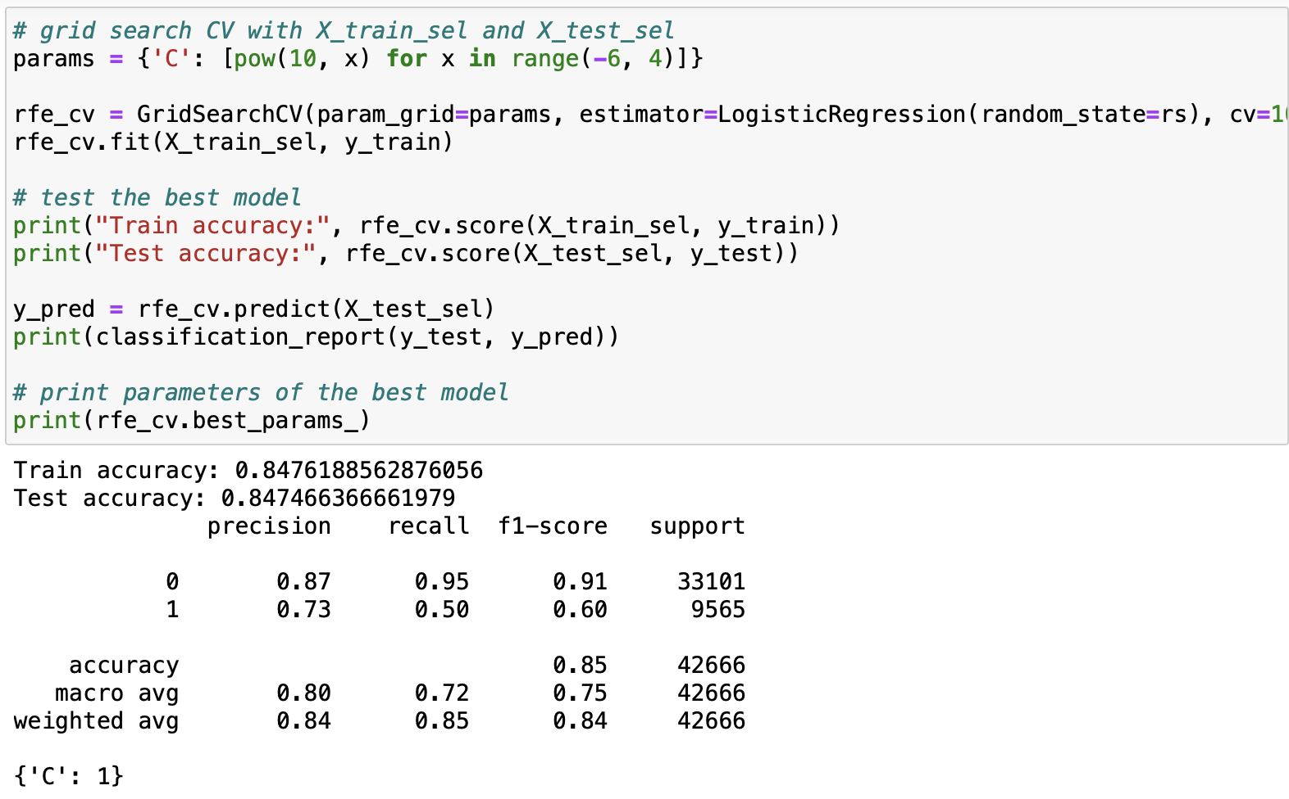

Answer: The training accuracy is 0.848 and the test accuracy is 0.847.

c. Report any sign of overfitting.

Answer:

No, it can be seen in train accuracy 81% and test accuracy 81% which are very close to each other. This means its prediction correctness is matching to training accuracy and has no overfitting problem.

d. Report the top-3 important variables (in the order) in the model.

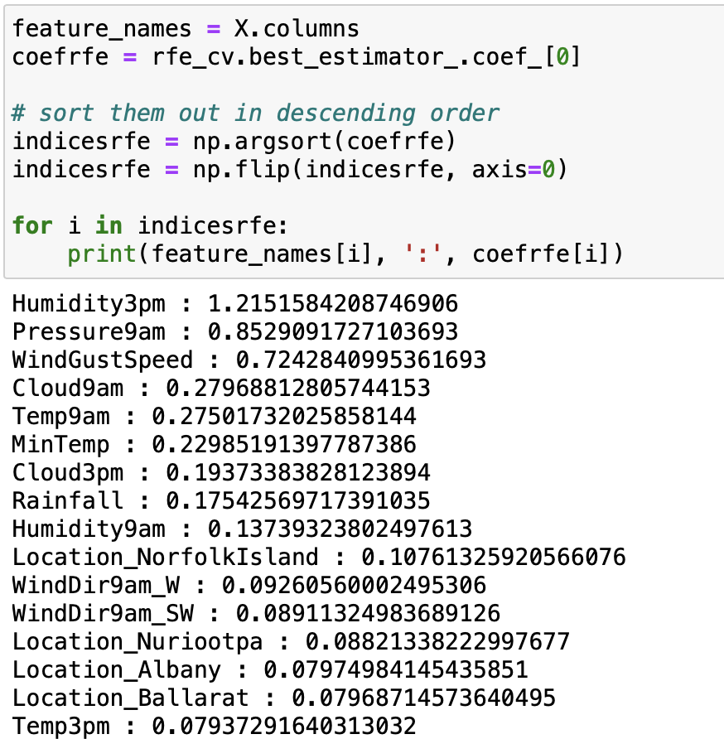

Answer:

The top three important variables in the model are “Humidity3pm”, “Pressure9am” and “WindGustSpeed”.

4. Produce the ROC curve for all different regression models. Using the best regression model, can you provide general characteristics that infer the model to predict rain tomorrow?

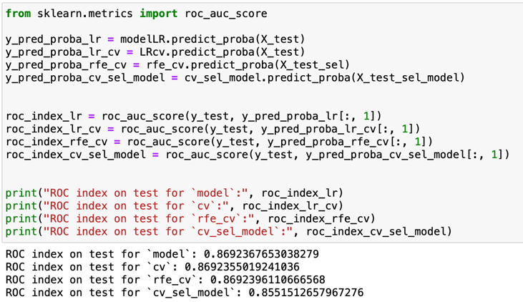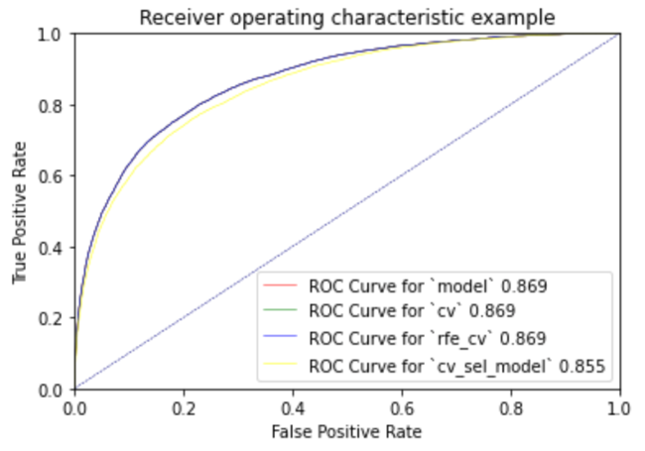

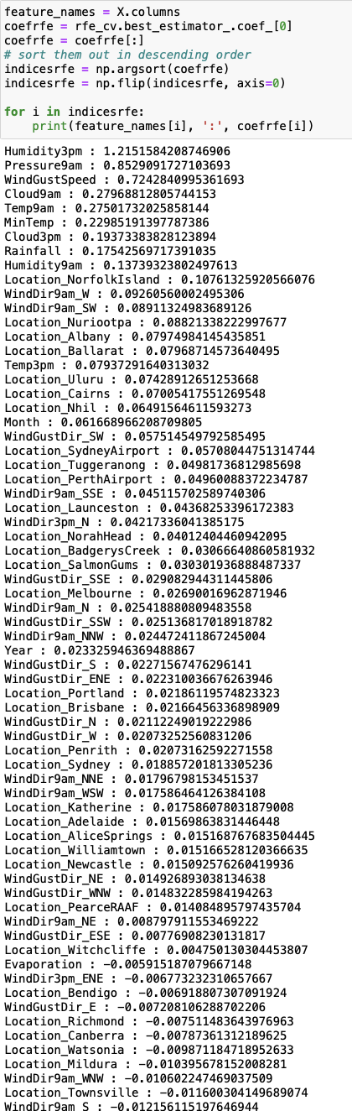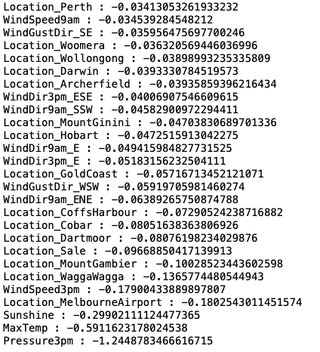

Answer:

The logistic regression model assumes a linear correlation between input features and target values. Therefore, the relationship is representing its importance and weight of the values. In fact, the absolute coefficient value tells about how importantly correlated the feature is. The relatively very positive coefficient which are “Humidity3pm”, “Pressure9am”, “WindGustSpeed”, meaning a change in these input features will cause positive correlation to the predicted value which is Rain Tomorrow. Let’s say if there are high “Humidity3pm”, “Pressure9am” and “WindGustSpeed”, meaning Rain Tomorrow are predicted to be more likely to rain tomorrow.

On the other hand,  The relative very negative coefficient which are “Pressure3pm”, “MaxTemp” and “Sunshine”, meaning a change in these input features will cause negative correlation to the predicted value to Rain Tomorrow. Let’s say if there are also high in “Pressure3pm”, “MaxTemp” and “Sunshine”, meaning Rain Tomorrow are predicted to be less likely to rain tomorrow.

**Predictive modelling using Neural Networks**

1. What processing was required on this pre-processed dataset (D3.csv) to further improve the data quality for neural network modelling? What distribution split between training and test datasets have you used?

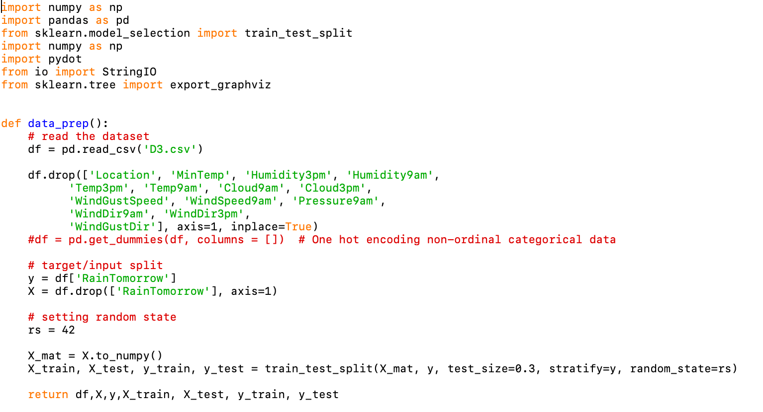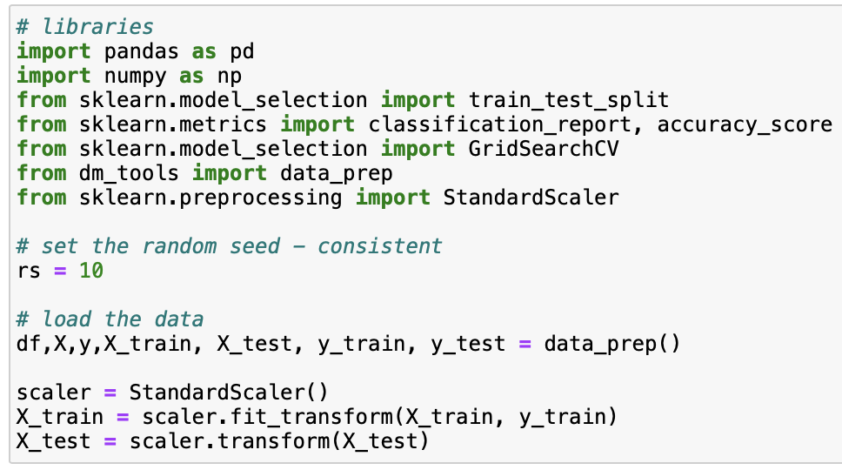

Answer:

The preprocessed dataset for doing neural networks is prepared using dm_tools. The content and required features are the same with the decision tree, by filtering them away with coefficient correlation. Then apply a standardscaler to the dataset and keep aligned to the same measurement. It would improve the data quality as most of the duplication variables are removed and standlised the data to improve the prediction quality and accuracy. The distribution split for training and test datasets are 0.7 to 0.3. It would be fair and efficient to use the same distribution split in decision tree, regression and neural networks as for the comparison in the later session.

2. Build a Neural Network model using the default setting. Answer the following:

a. Explain the parameters used in building this model, e.g., network architecture, iterations, activation function, etc.

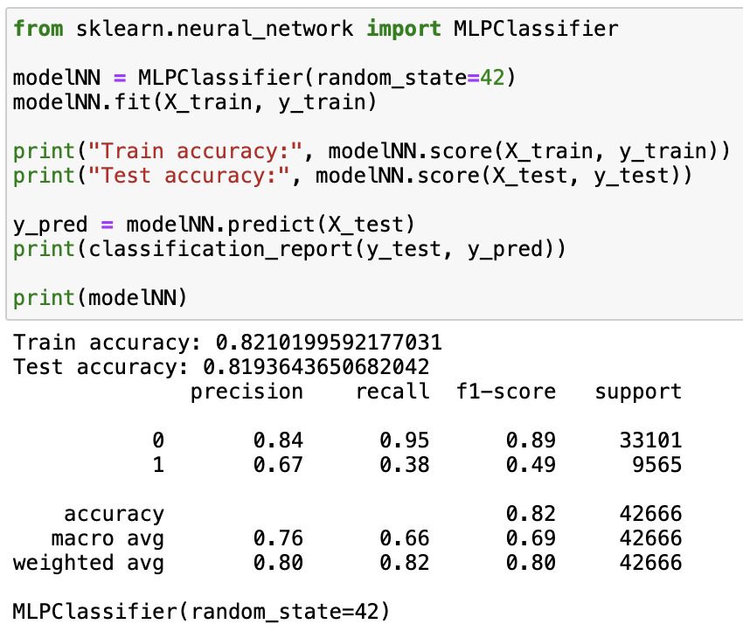

Answer:

The maximum iteration of default setting is 200. In this case it perfectly achieves the convergence before maximum iteration. In some cases, it needs to increase the maximum iteration to handle convergence.  In some extreme cases, the network still fails to reach convergence even with the high maximum iteration, it will cause error computation.

b. What is the classification accuracy on training and test datasets?

Answer: As seen in question A, Train accuracy is 0.82 and Test accuracy is  0.82.

c. Did the training process converge and result in the best model?

Yes, the first training process did not reach the maximum iteration which is 200 in the default setting. Therefore, it is enough to make the model converge. It is assumed the result is in the best model and has no sign of overfitting to the training data.

3. Refine this network by tuning it with GridSearchCV. Report the trained model.

a. Explain the parameters used in building this model, e.g., network architecture, iterations, activation function, etc.

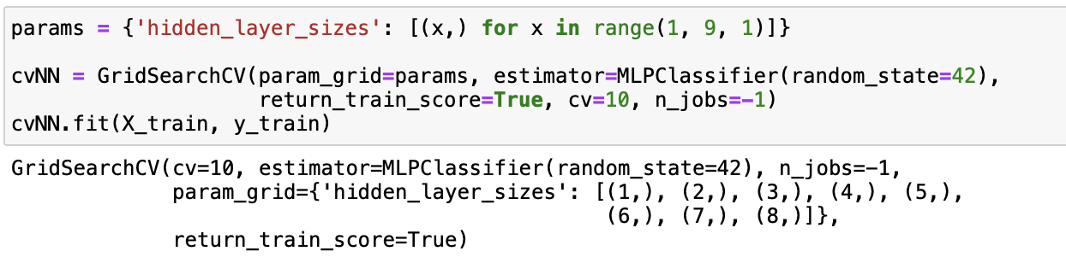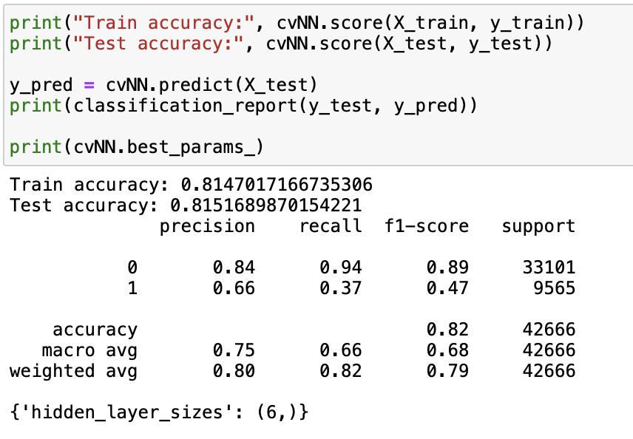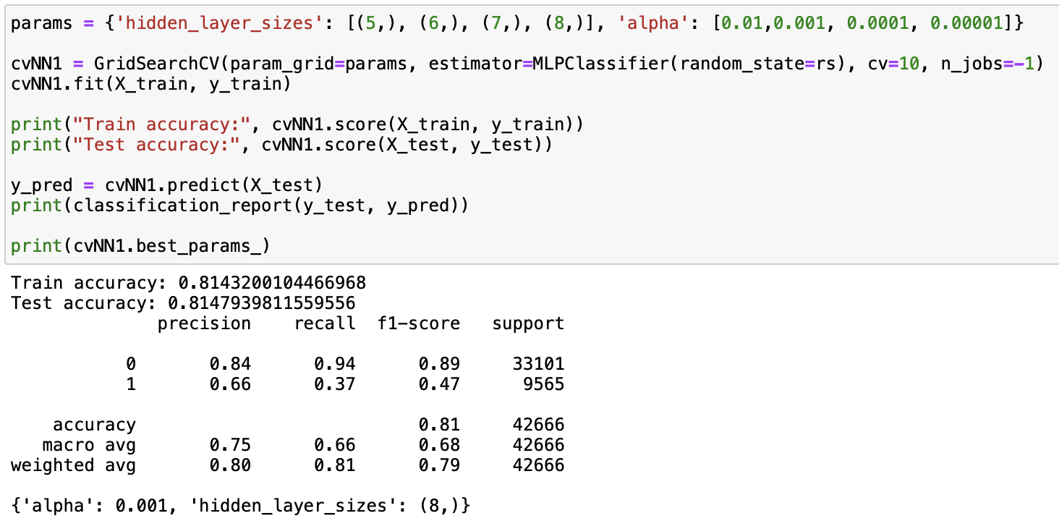

Answer:

Using GridSearchCV to find the optimal hyperparameters, for neural networks, hidden_layer_sizes is 8 which means the values of each tuple contain 8 elements of neurons in each hidden layer. And alpha is 0.01 which is L2 regularization parameter in the learning rate for the gradient descent algorithm  that is used in each neuron’s activation function. A larger alpha means the gradient descent takes bigger steps and the train can be faster, however, it can easily miss the optimal solution. Oppositely, smaller alpha means small steps will lead to slow training speed.

b. What is the classification accuracy on training and test datasets?

Answer: Train accuracy is 0.814 and test accuracy is 0.815.

c. Did the training process converge and result in the best model?

Answer: Yes, it is the best model as  the networks do not reach the maximum iteration. GridSearchCV can further control the overfitting of the model to the training data.

d. Do you see any sign of over-fitting?

Answer: No, since the training accuracy and test accuracy are very close.

4. Let us see if feature selection helps in improving the model? Build another Neural Network model with reduced features set. Perform dimensionality reduction by selecting variables with a decision tree (use the best decision tree model that you have built in the previous modelling task). Tune the model with GridSearchCV to find the best parameters setting.

a. Did feature selection favour the outcome? Any change in network architecture? What inputs are being used as the network input?

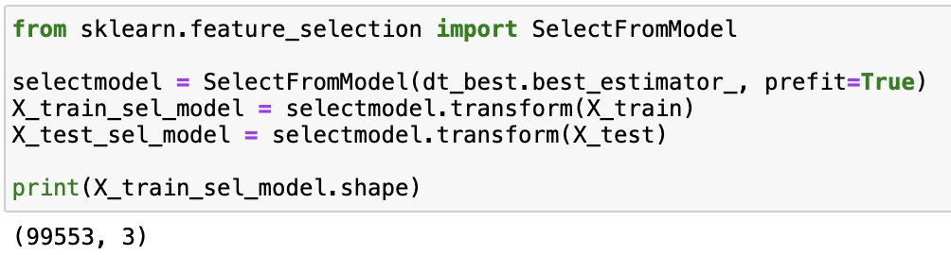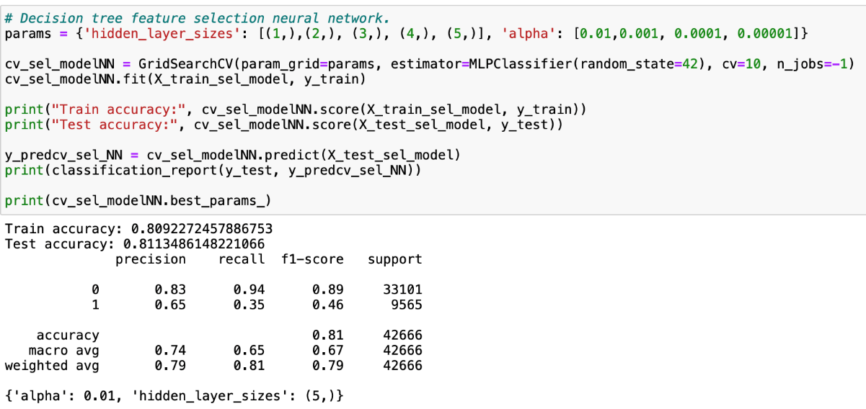

Answer:

The RFE feature selection shows improvements over the original dataset from 8 features to 3 features. However, comparing the model with (cvNN1) it did not improve model performance. The new network input: Using GridSearchCV to find optimal hyperparameters and results are alpha 0.01 and hidden_layer_sizes is 5.

b. What is the classification accuracy on training and test datasets?

Answer: Train accuracy is 0.81 and test accuracy is 0.811

c. How many iterations are now needed to train this network?

Answer: The default setting which is 200 iterations is enough to train this network.

d. Do you see any sign of over-fitting? Did the training process converge and result in the best model?

Answer:

No, since the training accuracy and test accuracy are very close. There is no overfitting. As there was no warning about maximum iterations reached, it indicates the model is well converged and it can be the best model so far.

5. Produce the ROC curve for all different NNs. Now, using the best neural network model, can you provide general characteristics that infer the model to predict rain tomorrow? If it is difficult (or even infeasible) to comprehend, discuss why?

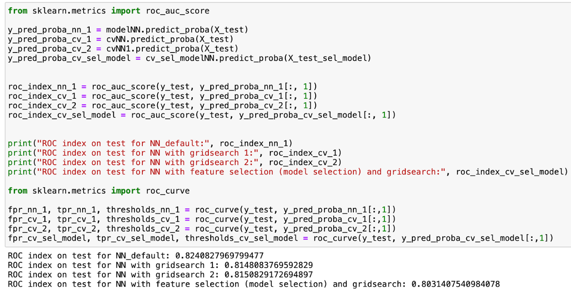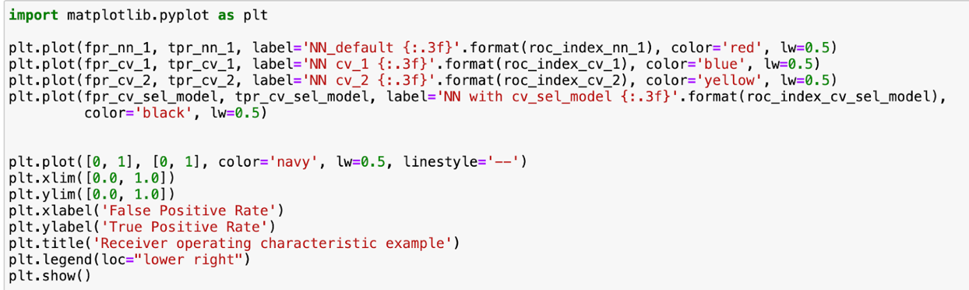

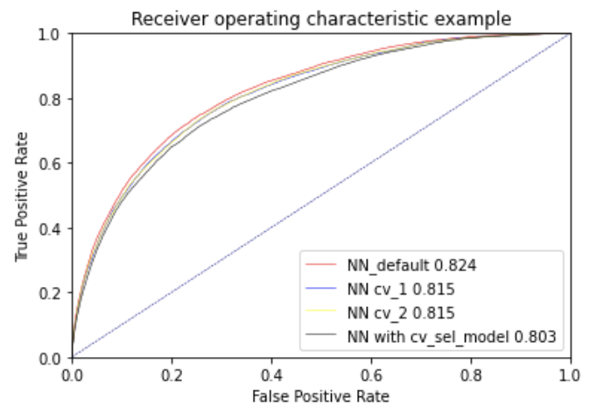

Answer:

Based on the ROC curve, the best neural network model is modelNN_default with ROC index of 0.824 which is the one with default settings. It is not possible to provide a general characteristic of model prediction to the rain tomorrow, since it is impossible to know the actual training process with the neural network due to its complexity.

Final remarks: Decision making

1. Finally, based on all models and analysis, is there a model you will use in decision making? Justify your choice. Draw a ROC chart and Accuracy Table to support your findings.

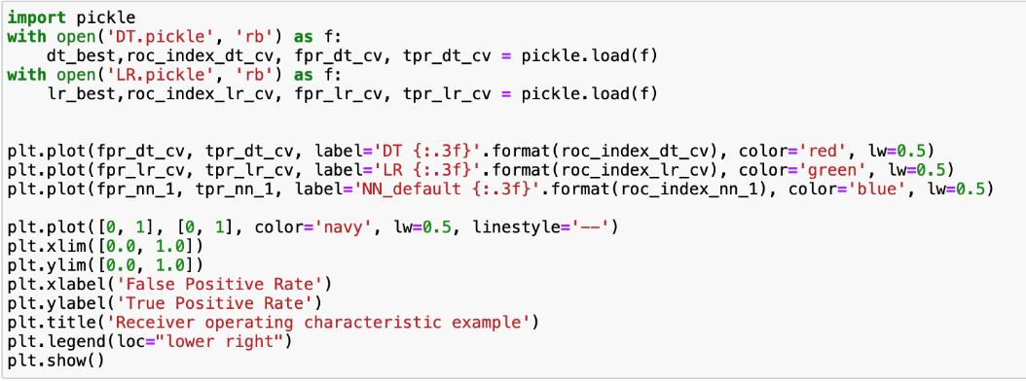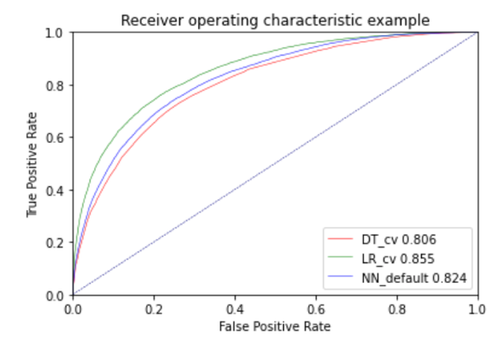

Decision Tree:

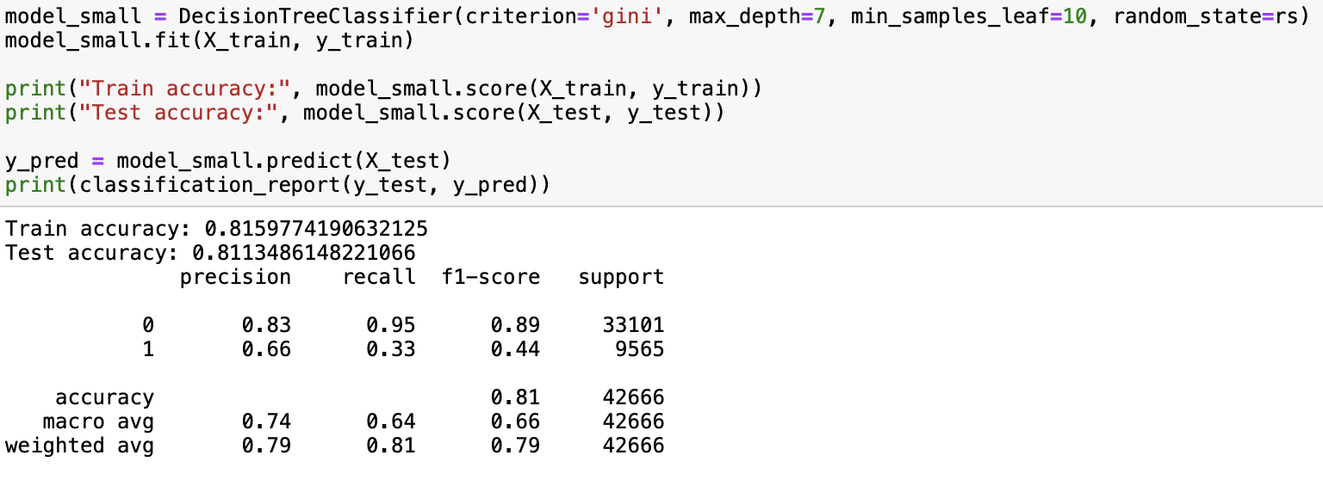

Logistic Regression:

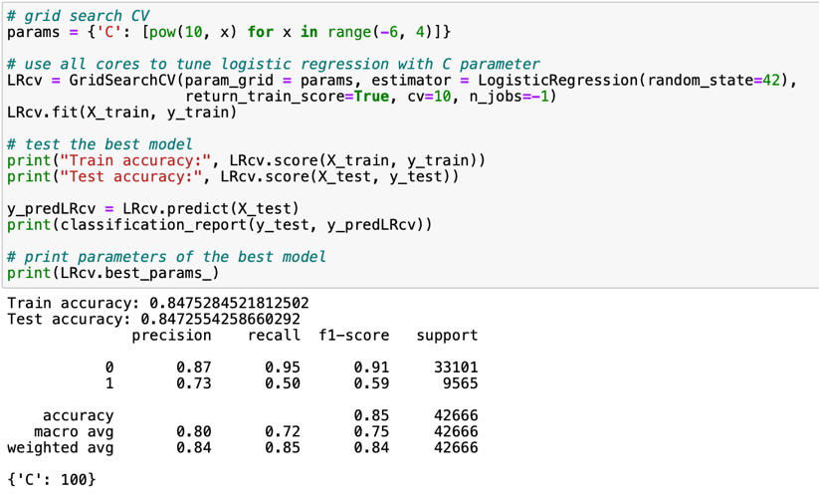

Neural Networks:

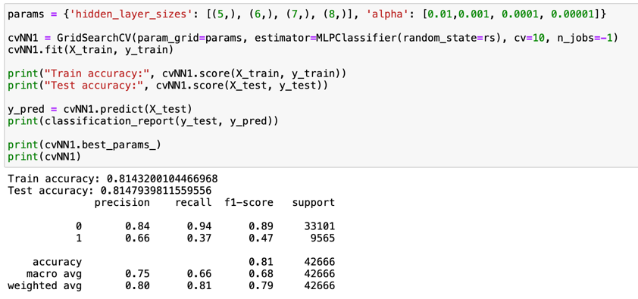

Answer:

According to the ROC curve, the best predictive model is the logistic regression model with GridSearchCV. Comparing it with the accuracy tables, Logistic Regression with CV is 0.855 is higher than the train and test accuracy of other models in general. It can conclude that LR_cv is the best model for  this prediction task.

2. Can you summarise the positives and negatives of each predictive modelling method based on this analysis?

Answer:

**Decision tree**

The advantage of clustering is that it is possible to divide the cluster into any number according to the purpose by following the tree diagram in order from the top. By creating a tree diagram, it can visually grasp the connection between data and use it for analysis. For example, from the purchase history of customers, it is possible to analyse the characteristics of customers who are likely to purchase/purchase their products and services and analyse the impact On the other hand, the disadvantage of clustering is its large amount of calculation. Since all the data combinations are calculated to form a cluster one by one, the larger the number of data, the larger the amount of calculation. If there is too much data, it will be difficult to read and utilise a tree. It can be said that big data with a huge number of data is not suitable for clustering. In addition, creating a model that overfits the exception value causes overfitting. The deeper the tree hierarchy, the more likely it is that there is a risk of overfitting.

**Logistic Regression**

During our data mining, Logistic regression is the fastest one to generate the result. In general, it is the fastest method among these three because it only involves comparison between the logistic function and the value points. It is faster to compare with a decision tree or neural network which involves more data training, testing, etc.  Moreover, the Logistic Regression is easy to interpret since we can see how factors influence the result. Overfitting is less likely to happen because data analysts can perform data standardisation before mining.

One major disadvantage of Logistic regression is the sigmoid function is difficult to apply to any real-world case. Also, it is sensitive to outlier values which may greatly affect the result. Extra time needs to be spent on data cleaning compared to a neural network.

**Neural Network**

For Neural networking, it can find more complicated class boundaries for different datasets. Compared with the decision tree, which looks for characteristics of the output, it looks for the best combination of weights of those notes, which means it can be used for both regression and classification purposes. The second pro is neural work can handle non-numerical values, even images. The third pro is it has a first application speed, which means once the model is established, users can get the result relatively faster than other methods.

On the other hand, it takes a lot of time and money to complete the model because it requires a lot of data training to adjust the weights of the nodes. It also leads to another problem which is overfitting, more training the model took, harder for it to be generalised to other datasets resulting in poor accuracy. The third problem is that the neural network is a black box process, which means the data analysts would not know how much a node weighs or which nodes influence the result. This makes it difficult for data analysts to use the result of neural networks to explain the reason for certain phenomena compared with the decision tree or regression.